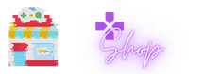

**GAMES SHOP**

**Software Requirement Specification**

–Hanoi, April 2022 –

* **Record of changeS**

|  |  |  |  |
| --- | --- | --- | --- |
| **Date** | **A*, M, D** | **In charge** | **Change Description** |
| 14/4/2022 | A | Sơn | Add context diagram and screen flow |
| 18/4/2022 | M | Sơn | Fix screenflow and context diagram |
|  |  |  |  |
|  |  |  |  |
|  |  |  |  |
|  |  |  |  |
|  |  |  |  |
|  |  |  |  |
|  |  |  |  |
|  |  |  |  |
|  |  |  |  |
|  |  |  |  |
|  |  |  |  |

*A - Added M - Modified D - Deleted

# Table of Contents

I. Overview 4

* 1. Introduction 4
* 2. System Functions 5
* II. Functional Requirements 7
* 1. <<Feature Name 1>> 7
* a. <<Function Name 1>> 7
* b. <<Function Name 2>> 7
* 2. <<Feature Name 2>> 7

|  |  |
| --- | --- |
| Actor | Description |
| Users | Everyone view and use website |
| Staff | Staff is summary of all user who can control website system |
| Admin | Highest roll can control account, product and blog |
| Marketing | This roll can write, edit blog and answer FQAs question |
| Seller | This roll can control product like add product change/edit product and accept or reject order of customers |
| Customers | This user can buy and give feedback on product |

# Overview

Games Shop was built to help Organizations and many Professionals create and sell their online entertainment genres, and customers can play games with accounts with discounted prices and bundled promotions. The document that accompanies them when they purchase a game account distributed by the manufacturer.

The main advantage of this system is that customers can buy anytime, anywhere using a variety of devices such as smartphones, tablets and computers. This can be an alternative form for customers (Especially students) to be able to play hot games in foreign countries that require a separate account and pay fees.

Devine Shop gives you quick and safe access to local and international video games.

## Introduction

## 

**Figure 1.1.1**: Context diagram

* This website is about game online selling codes, credits.

## System Functions

#### Screen Flow

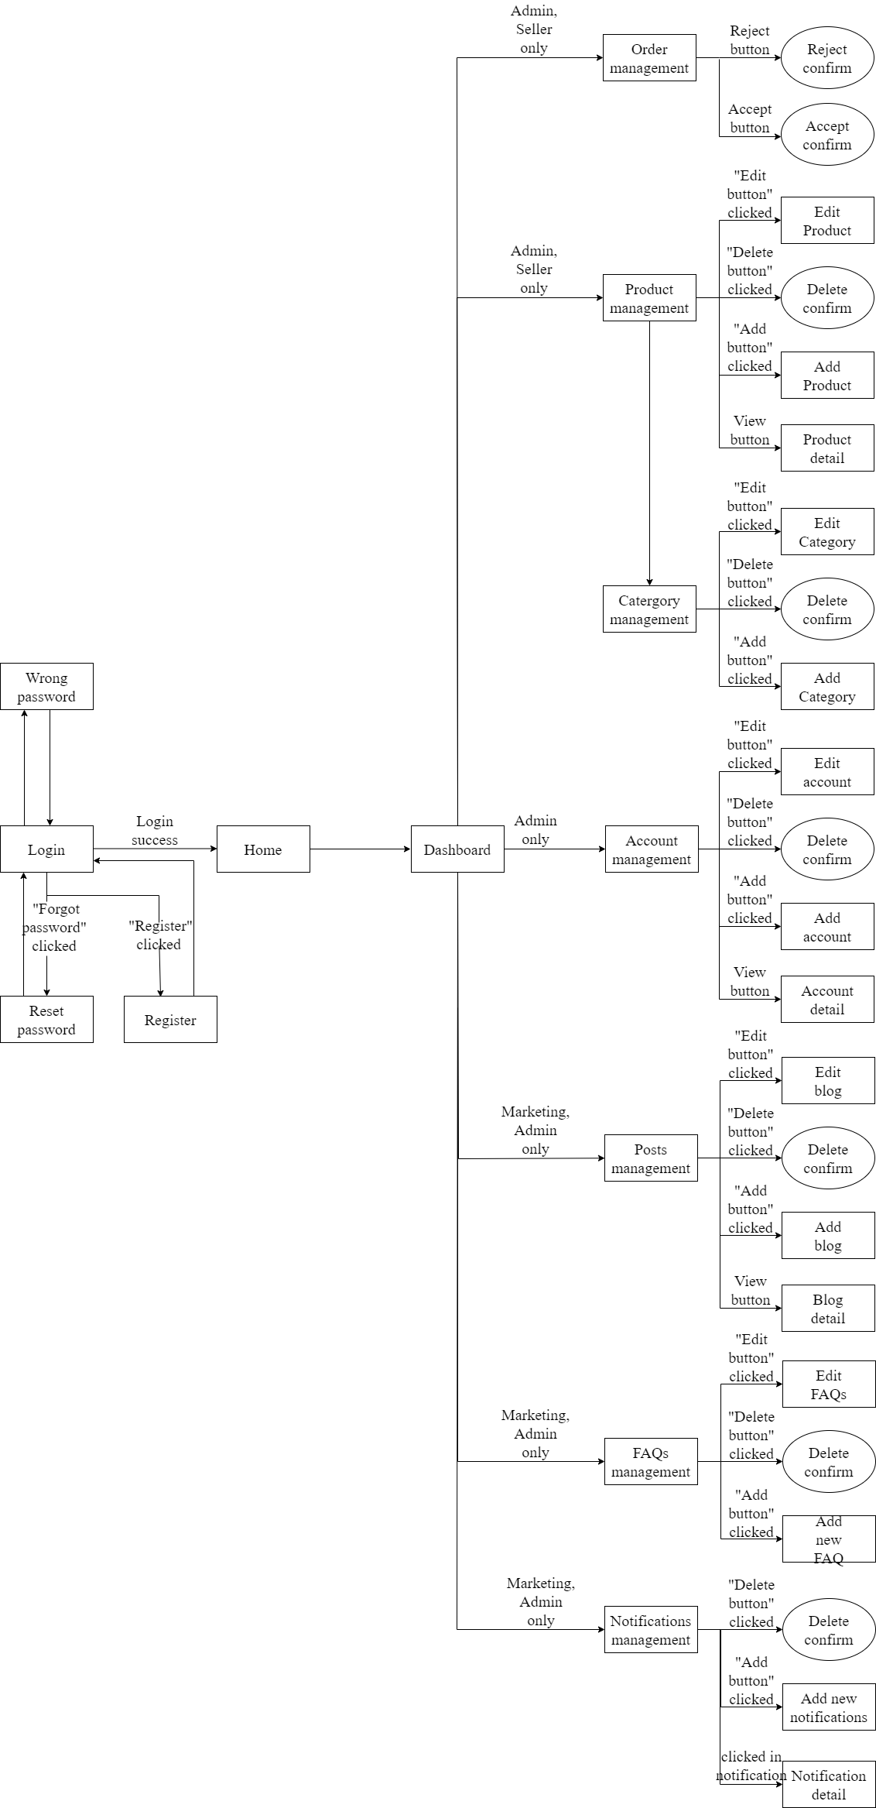

**Figure 1.2.1**. Staff screen flow

#### 

**Figure 1.2.2.** Customers screen flow

1. **Screen Details**

|  |  |  |  |
| --- | --- | --- | --- |
| **No** | **Function/Screen** | **Feature** | **Function/Screen Details** |
|  | User Register | Common | This is a screen which allows user register new account by input following information: full name, gender, email, mobile; User need to verify by clicking the link sent via email before login into system |
|  | Reset Password | Common | This is a screen which allows user find account they forgot thought email register. User input email and click in reset password they will receive a mail contain reset password link.  This link will redirect user to password reset form allow user can change password of these own account without old password. |
|  | Wrong password | Common | This is a screen will show message when user input wrong information of login account (password or email)  This screen will auto redirect back in login page |
|  | Login | Common | This is a screen show login form for user want to login in to website |
|  | Profile detail | Common | This is a screen which allows user to view their own profile information, including all personal information & avatar image.  User can change profile detail by click in edit button to redirect in edit profile screen.  User can view order history by click in order history button |
|  | Order history | Common | This screen show information of all game their buy in history(OrderID , Productname, price, date,status) |
|  | Edit profile | Common | This is a screen which allows user to edit their own profile information, including all personal information & avatar image.  Note user not allowed to change email |
|  | Change Password | Common | This is a screen allows the user to change their password by input current password to verifies |
|  | Home | Common | Show sliders, hot posts, featured subjects + the sider with the latest posts, static contacts/links  Shown slider information includes its image and title; the user is redirected to the slider's backlink on their clicking  Show post information includes its thumbnail, title, post date; the user is redirected to the post's details on his/her clicking  Show subject information includes its thumbnail, title, tag line; the user is redirected to the subject's details on their clicking |
|  | Notification list | common | Customers can see all title notification of their account, list by pagination with information (id, title, status, time).  The customers can filter the notifications by status  Allow the customers to search notifications by name |
|  | Notification detail | common | Show detail notification information(id, Content, status, time) |
|  | Product | Common | Show list product the right side with the post search box, product categories, eight featured products (thumbnail, title, price); Product information includes its thumbnail, title, category, brief-info; the user is redirected to the Product Details page on his/her clicking on a product, redirected to this Product List page if the user clicks on a product category |
|  | Product Detail | Common | Show details (including name, thumbnail, brief info, lowest price plan option (original price, discount price), product description and Buy button) of product user choose in product list  User can increase or decrease the number of products added to the cart  After choose right amount of product user can click in add to cart button to put product in cart to buy it later |
|  | Cart | Common | All product user put to cart prepare to payment  Customer can change detail cart (product) beford checkout  After check all information correct user can checkout |
|  | Checkout | Common | This screen will show all information of your order (OrderID , ProductName, User information, price, date)  After check all information is correct click in payment button to view payment screen |
|  | Payment information | Common | This screen will guide users how to payment their order will full information of bank account , content transfer, price user need to pay |
|  | About Us | Common | This is a screen allow user contact to admin by input following information: full name, user title (Mr, Mrs, Ms,..), email, mobile, address; |
|  | Posts List | Common | Show blog list with the post search box, posts categories, latest posts, static contacts/links; Show post information includes its thumbnail, title, category, brief-info; the user is redirected to the post's details on their clicking |
|  | Port Details | Common | Show details (including title, author, updated date, category, and post details) of blog user choose in blogs list |
|  | Dashboard | Admin, seller, marketing | This screen for staff only  It give all staff member abilities to change information in system depend on their roll |
|  | Order Management | Admin | Admin can see all order list by pagination with information (id, Total Price, date, note).  admin can filter the orders by status  Allow admin to search orders by name  From each order, admin can choose to view detail  Show detail order with information(id, Total Price ,date , note) can view, edit/update the information of the order |
|  | Product Management | Admin | Admin can see all product list with information(id, name, thumbnail, original price, sale price, category, status, description).  Admin can filter the products by status  Allow the admin to search products by name  Admin can choose view product their choose  Admin can add new product in to product list  Show detail product information (id, name, thumbnail, original price, sale price, category, status, description)  The admin can edit/update the information of the product |
|  | Category Management | Admin | Admin can see all category list with information(id, category name).  Allow the admin to search category by name  Admin can choose view category their want  Admin can add new category in to category list  The admin can edit/update the information of the product |
|  | Account Management | Admin | Show the paginated list of accounts (include user id, full name, gender, email, mobile, role, status):  The admin can filter the account by role, status  Allow the admin to search accounts by full name, email…  From each account, admin can choose to view or edit it  The page also have the button/link that allows the admin to add new account |
|  | Posts Management | Marketing, Admin | Admin and marketing roll can see all blog list by pagination with information(id, author, title, content, image).  Admin and marketing can filter the blogs by date and name  Admin and marketing can search blogs by name  Admin and marketing can choose blog to view detail and edit  Admin and marketing can write new blog  Show detailed blog information (id, author, title, content, image)  Admin and marketing can edit/update the information of the blog |
|  | Notification Management | Admin | Admin can see all notification list by pagination with information(id, UserID, OrderID, Content, status, time).  The admin can filter the notifications by status  Allow the admin to search notifications by name  Show detailed notification information(id, UserID, OrderID, Content, status, time), allow the admin to add new or view notification information |
|  | FAQs management | Admin, marketing | Admin and marketing roll can see all FAQs list by pagination with information(id, author, title, content, date).  Admin and marketing can filter the FAQs by date and name  Admin and marketing can search FAQs by name  Admin and marketing can choose FAQs to view detail and edit  Admin and marketing can write new FAQs  Show detailed FAQs information (id, author, title, content, date)  Admin and marketing can edit/update the information of the FAQs |
| 28. | Promotion management | Admin,  Seller | Admin, and marketing roll can see all Promotion lists by pagination with information(id, promotion code, sale percent, amount).  Admin and marketing can filter the promotion by date and name  Admin and marketing can search promotions by name  Admin and marketing can choose a promotion to edit  Admin and marketing can write a new promotion  Admin and marketing can edit/update the information of the promotion |
| 29. | Product Review | Customer,  Seller,  Marketer | At the product detail page, users can comment to review about the product. Seller or Marketing can reply to the user's review. |

#### c. User Authorization

|  |  |  |  |  |
| --- | --- | --- | --- | --- |
| **Screen** | **Admin** | **Marketing** | **Seller** | **Customer** |
| Login | X | X | X | X |
| Home Page | X | X | X | X |
| Change Password | X | X | X | X |
| About Us | X | X | X | X |
| Check Out |  |  |  | X |
| Dashboard | X | X | X |  |
| Review | X | X | X | X |
| View Customer | X | X | X | X |
| Invalid Role | X | X | X | X |
| User Profile | X | X | X | X |
| Account Management | X |  |  |  |
| Reset Password | X | X | X | X |
| Cart |  |  |  | X |
| Error | X | X | X | X |
| Check out |  |  |  | X |
| Post management | X | X |  |  |
| List Post | X | X | X | X |
| Detail Post | X | X | X | X |
| Product list | X | X | X | X |
| Product Management | X |  | X |  |
| Order management | X | X | X |  |
| View Order Detail | X | X | X | X |
| View Order History | X | X | X | X |
| FQAs management |  | X |  |  |
| FQAs list | X | X | X | X |
| Category management | X |  |  |  |
| Notification management | X |  |  |  |

#### Non-Screen Functions

|  |  |  |  |
| --- | --- | --- | --- |
| **#** | **Feature** | **System Function** | **Description** |
| 1 | Database access | Read and write to database | Read and write to database |
| 2 | User authorise | Check account roll in database | Implementation of authorization mechanism in the system, including the specify the role of logged-in user, his/her authorized page links (building the displayed menu items (in the front end) and preventing unauthorized access via enter the links directly) |

# II. Functional Requirements

## Login

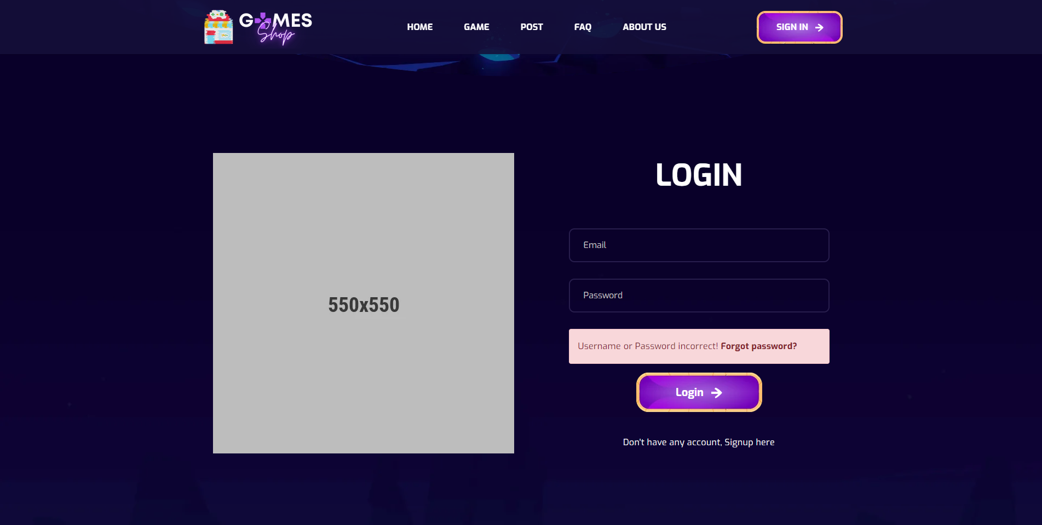

Figure 2.1.1: Login

|  |  |  |
| --- | --- | --- |
| **UI Element: Login page** | | |
| **UI Element Description** | | |
| ID | 1 | |
| Description | Login screen to user log in to system | |
| **UI Element Displays** | | |
| Precondition | Connect internet | |
| User not logged in | Screen show Login page | |
| User input wrong email or password | Screen show danger alert and Forgot password link | |
| **UI Element Behaviors** | | |
| **Precondition** | **Action** | **Respond** |
| User is not logged in | Click on Signin button at navbar | System will redirect to Login page |
| User is logged in | Input Login url page in browser | System will redirect to Homepage |

## Signup

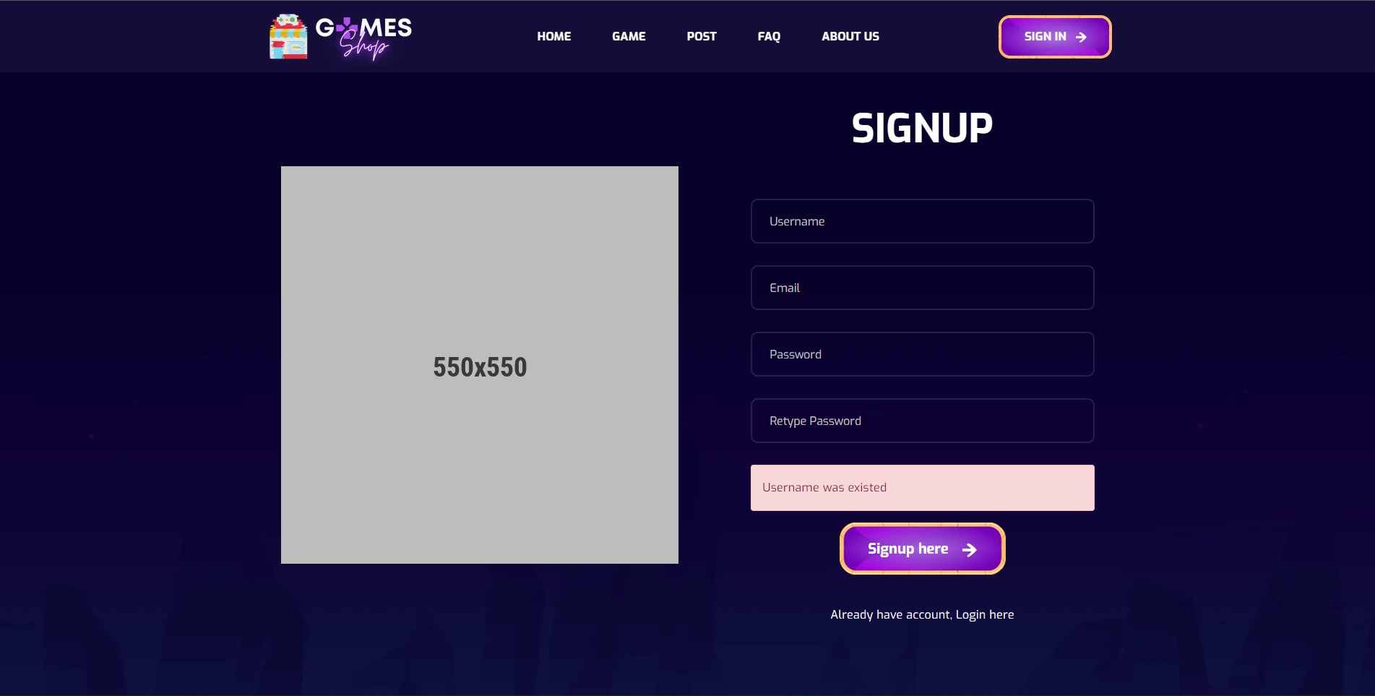

Figure 2.2.2. Signup

|  |  |  |
| --- | --- | --- |
| **UI Element: Signup page** | | |
| **UI Element Description** | | |
| ID | 2 | |
| Description | Signup screen to user register new account | |
| **UI Element Displays** | | |
| Precondition | Connect internet | |
| User not logged in | Screen show Signup page | |
| User input existed email or username | Screen show danger alert “Username / Email was existed” | |
| User input password and re-password not match | Screen show danger alert “Re-password not match” | |
| User registered new account success | Screen show success alert “Registered successfully” | |
| **UI Element Behaviors** | | |
| **Precondition** | **Action** | **Respond** |
| User is not logged in | Click on Signup link at Login page | System will redirect to Signup page |
| User is logged in | Input Signup url page in browser | System will redirect to Homepage |

## Forget password

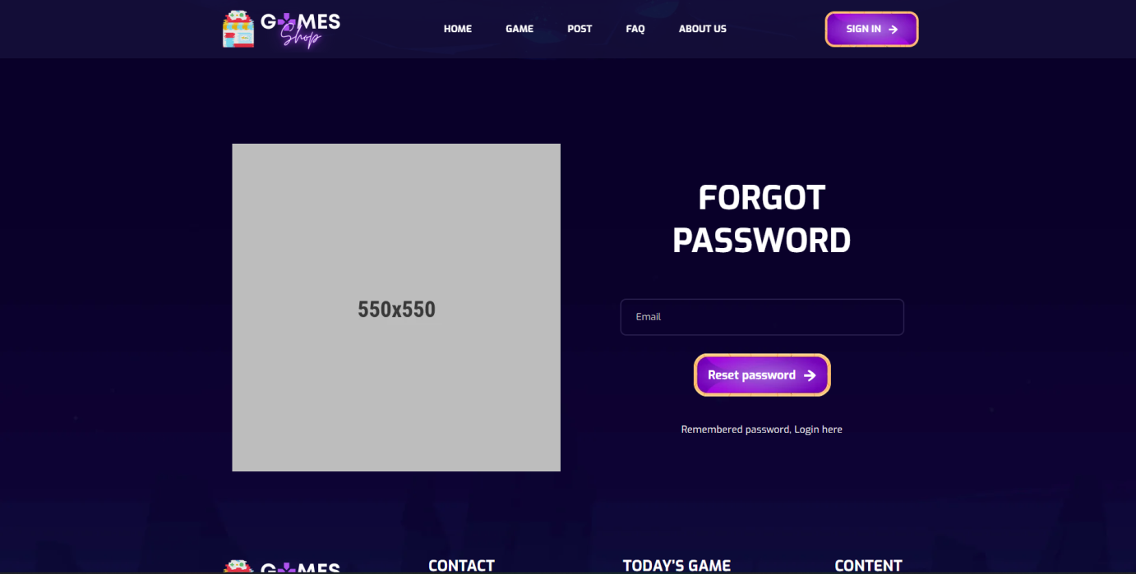

Figure 2.3.1: Forget password

|  |  |  |
| --- | --- | --- |
| **UI Element: Forgot password** | | |
| **UI Element Description** | | |
| ID | 3 | |
| Description | Forgot password page to user can input their account email to receive reset password link | |
| **UI Element Displays** | | |
| Precondition | Connect internet | |
| User not logged in | Screen show Forgot password page | |
| User input not exist email | Screen show danger alert “Email is not exist” | |
| User input exist email | Screen show success alert “Reset password link was sent to your email” | |
| **UI Element Behaviors** | | |
| **Precondition** | **Action** | **Respond** |
| User is not logged in | Click on Forgot password link at Login page | System will redirect to Signup page |
| User is logged in | Input Forgot password url page in browser | System will redirect to Homepage |

1. **Reset password**

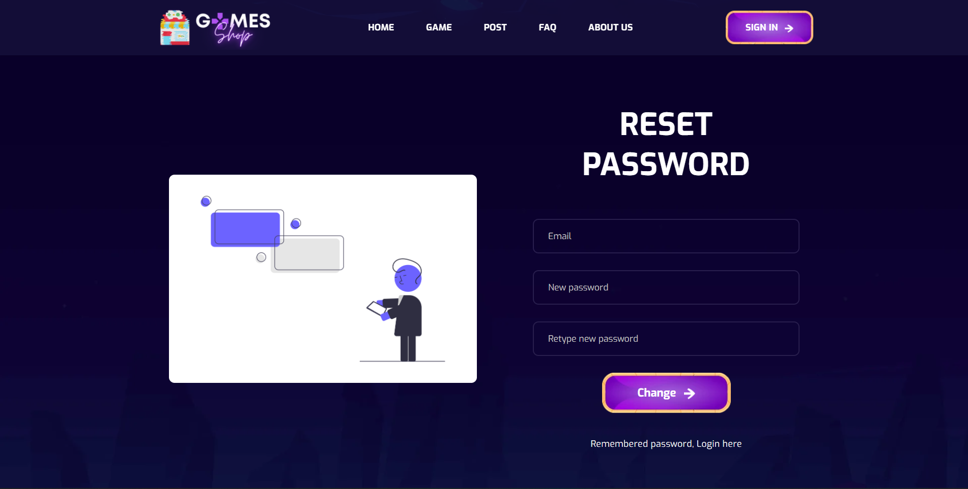

**Figure 2.4.1: Reset password**

|  |  |  |
| --- | --- | --- |
| **UI Element: Reset password** | | |
| **UI Element Description** | | |
| ID | 4 | |
| Description | Reset password page be access from link to user change their account password | |
| **UI Element Displays** | | |
| Precondition | Access from link | |
| User input password and re-password not match | Screen show danger alert “Re-password not match” | |
| **UI Element Behaviors** | | |
| **Precondition** | **Action** | **Respond** |
| User is not access with link | Input Reset password url page in browse | System will redirect to Reset Password page |
| User is access with link | Input Reset password url page in browse | System will redirect to Reset password |

## Homepage

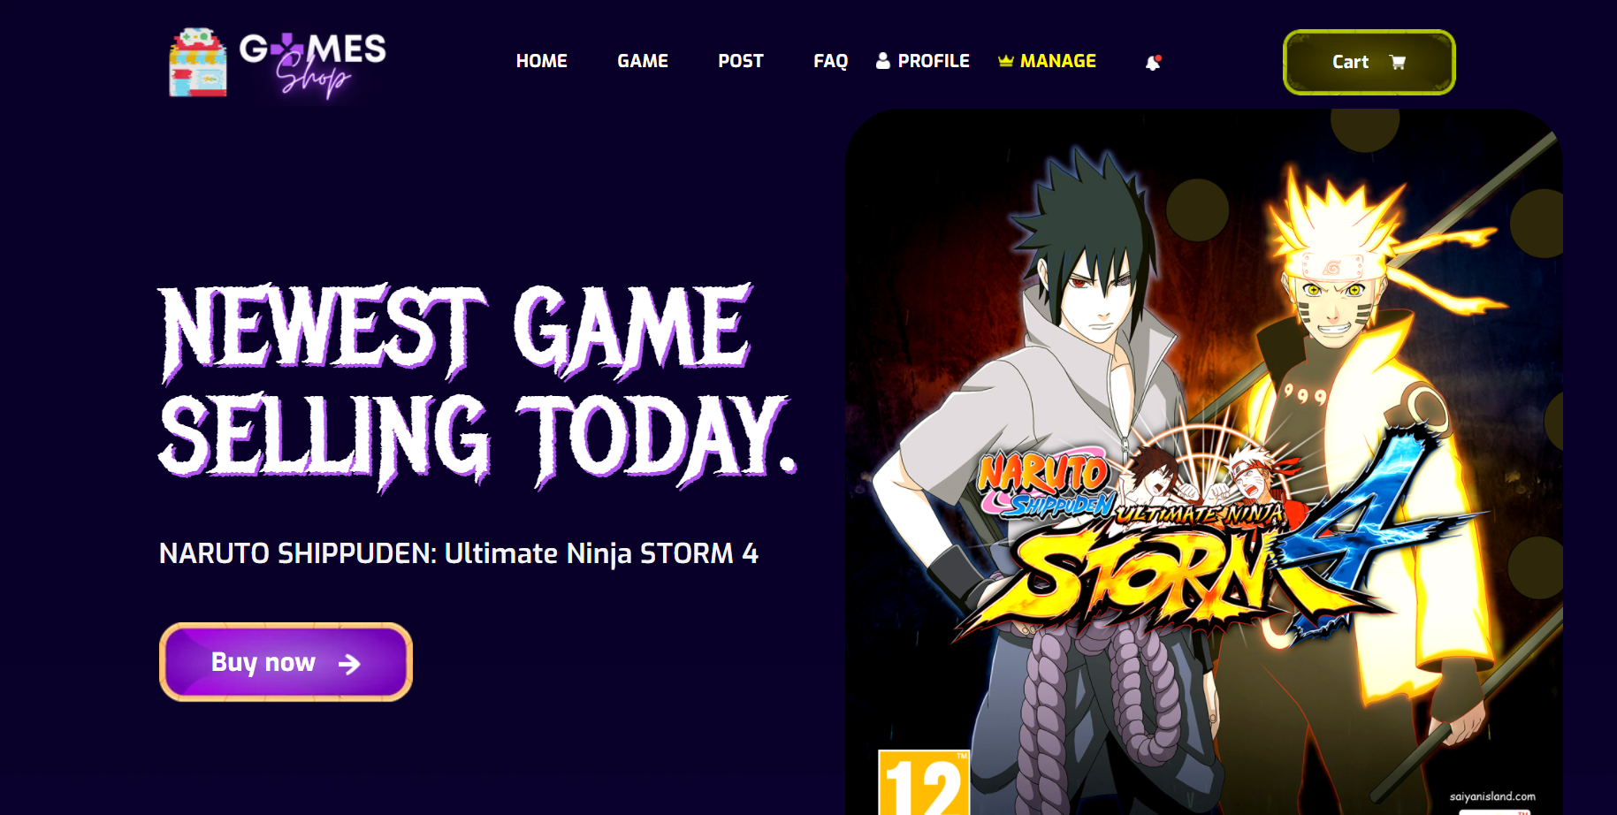

**Figure 2.5.1**: The home page shows the Latest game

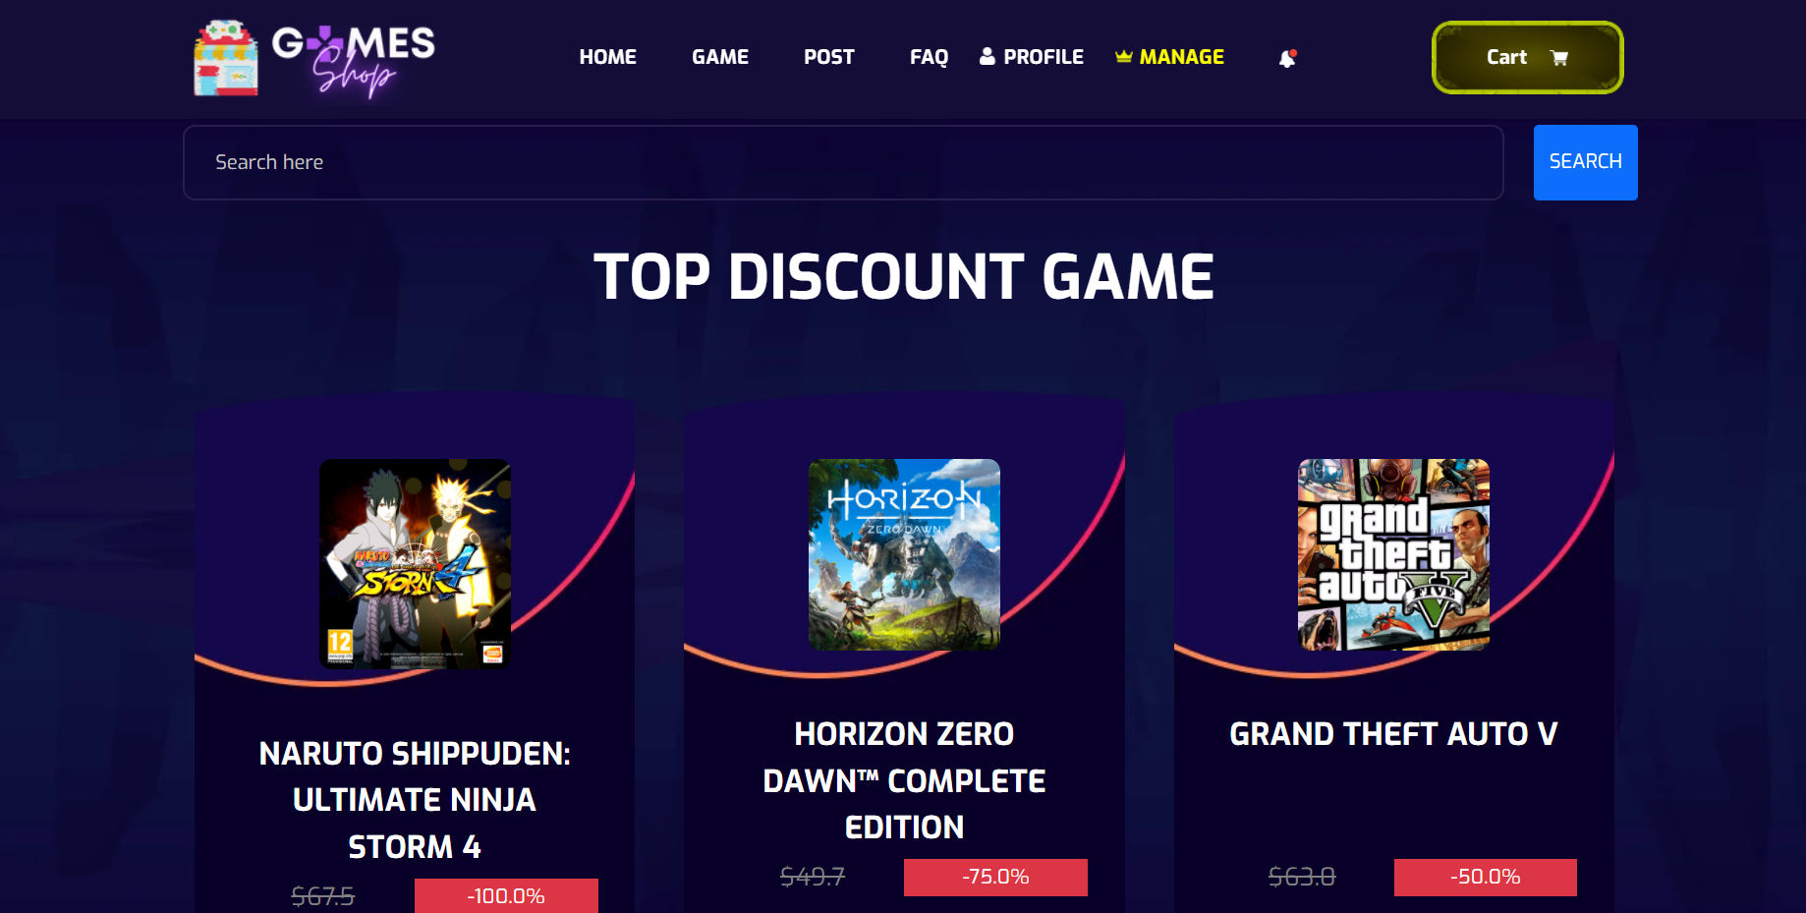

**Figure 2.5.2**: The home page shows the top discount game

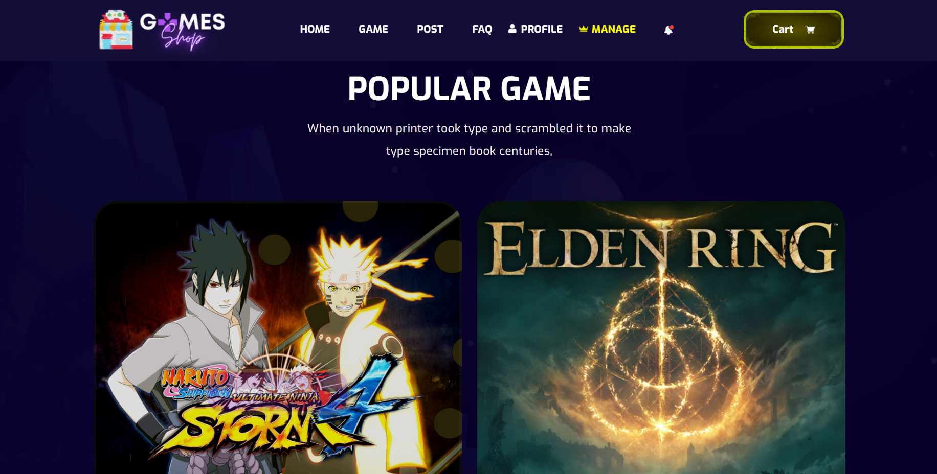

**Figure 2.5.3**: The home page shows the popular game

|  |  |  |
| --- | --- | --- |
| **UI Element: View Customer Information** | | |
| **UI Element Description** | | |
| ID | 5 | |
| Description | Screen show Homepage | |
| **UI Element Displays** | | |
| Precondition | Display | |
| Staff is not logged in | Screen show all product but doesn’t show Manager tabs in navigator bar | |
| Staff is logged in | Screen show all and Manager tabs in navigator bar | |
| **UI Element Behaviours** | | |
| **Precondition** | **Action** | **Respond** |
| Staff is not logged in | Input manage URL in browser | System will send back an error page and redirect back to home page |
| Staff is logged in | Click on manage in navigator bar or input manage URL in browser | System show screen of dashboard and navigator with full function for staff Includes: Product management, post management, category management, account management |
| Staff is not logged in | Input the product name in the search bar | Take the user to the page displaying the product they are looking for on the game page |
| Staff is not logged in | Click the button buy now, Product's name, detail | Take the user to the product detail display page |

## 6. Product

* 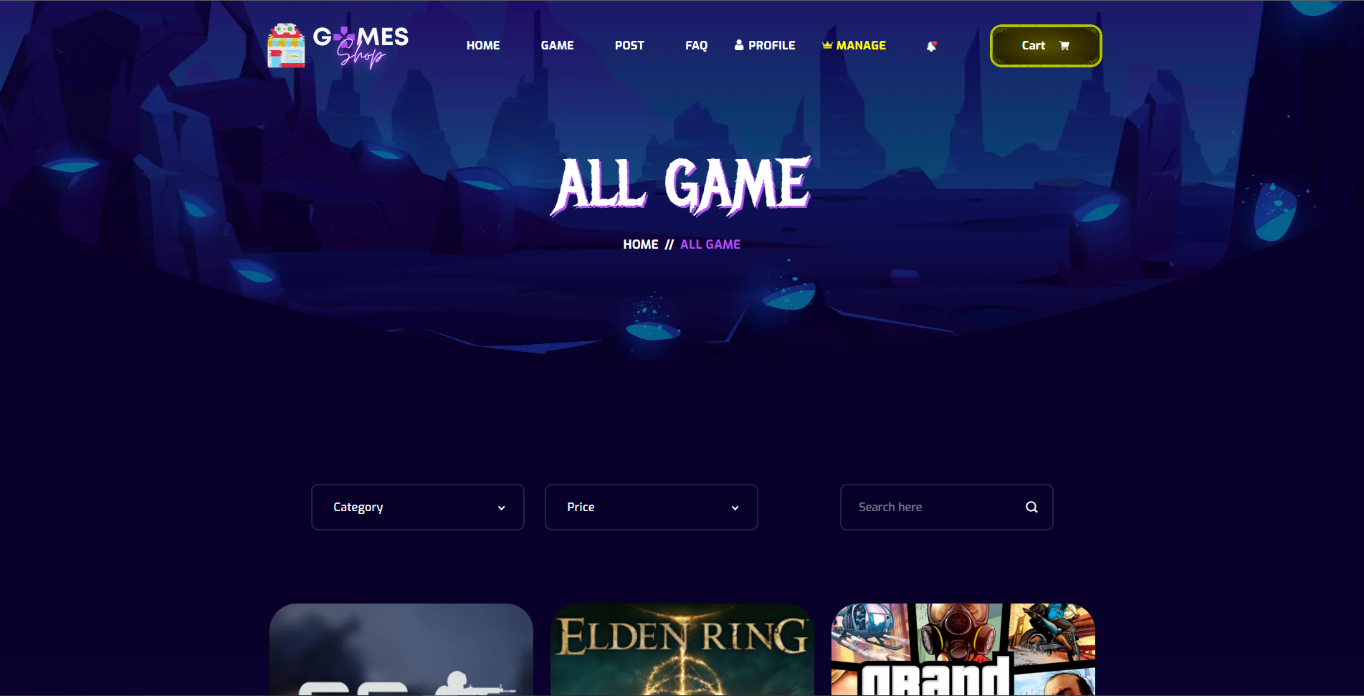

Figure 2.6.1: Show all the product

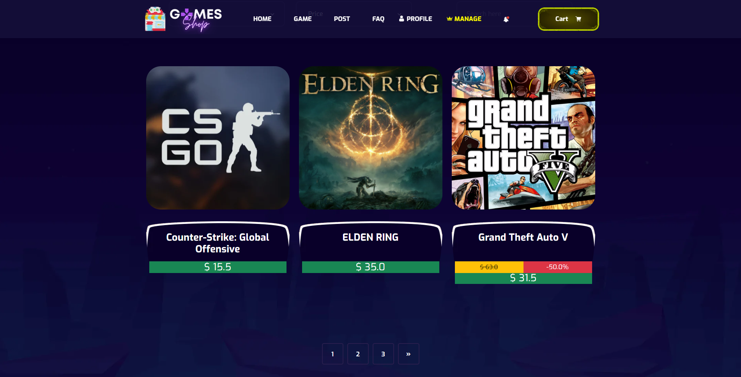

Figure 2.6.2: Show all the product

|  |  |  |
| --- | --- | --- |
| **UI Element: View Game Page** | | |
| **UI Element Description** | | |
| ID | 6 | |
| Description | Screen show Product | |
| **UI Element Displays** | | |
| Precondition | Display | |
| User is logged in | Screen show all product with percent discount and sell price but doesn’t show Manager tabs in navigation bar | |
| Staff is logged in | Screen show all and Manager tabs in navigator bar | |
| **UI Element Behaviours** | | |
| **Precondition** | **Action** | **Respond** |
| Staff is not logged in | Input manage url in browser | System will send back an error page and redirect back to home page |
| Staff is logged in | Click on manage in navigation bar or input manage url in browser | System show screen of dashboard and navigator with full function for staff Includes : Product management , post management, category management, account management |
| User | Click on the second page or another page | System shows other games on the second page or another page. |
| User | Click filter by category | System show games with category as selected |
| User | Click filter by price | System show games with price as selected |
| User | Click filter by text | System show games with text like they search |

## 7. Product detail

* 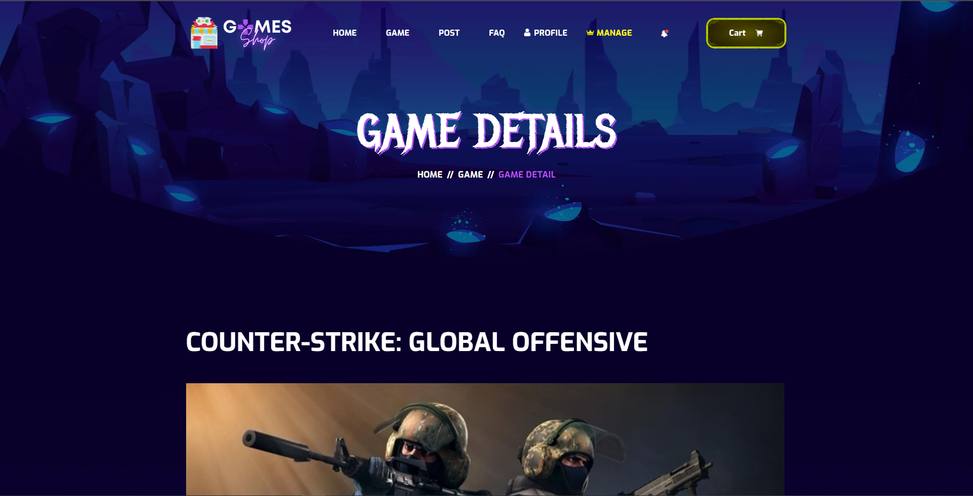

Figure 2.7.1: Product detail - title

* 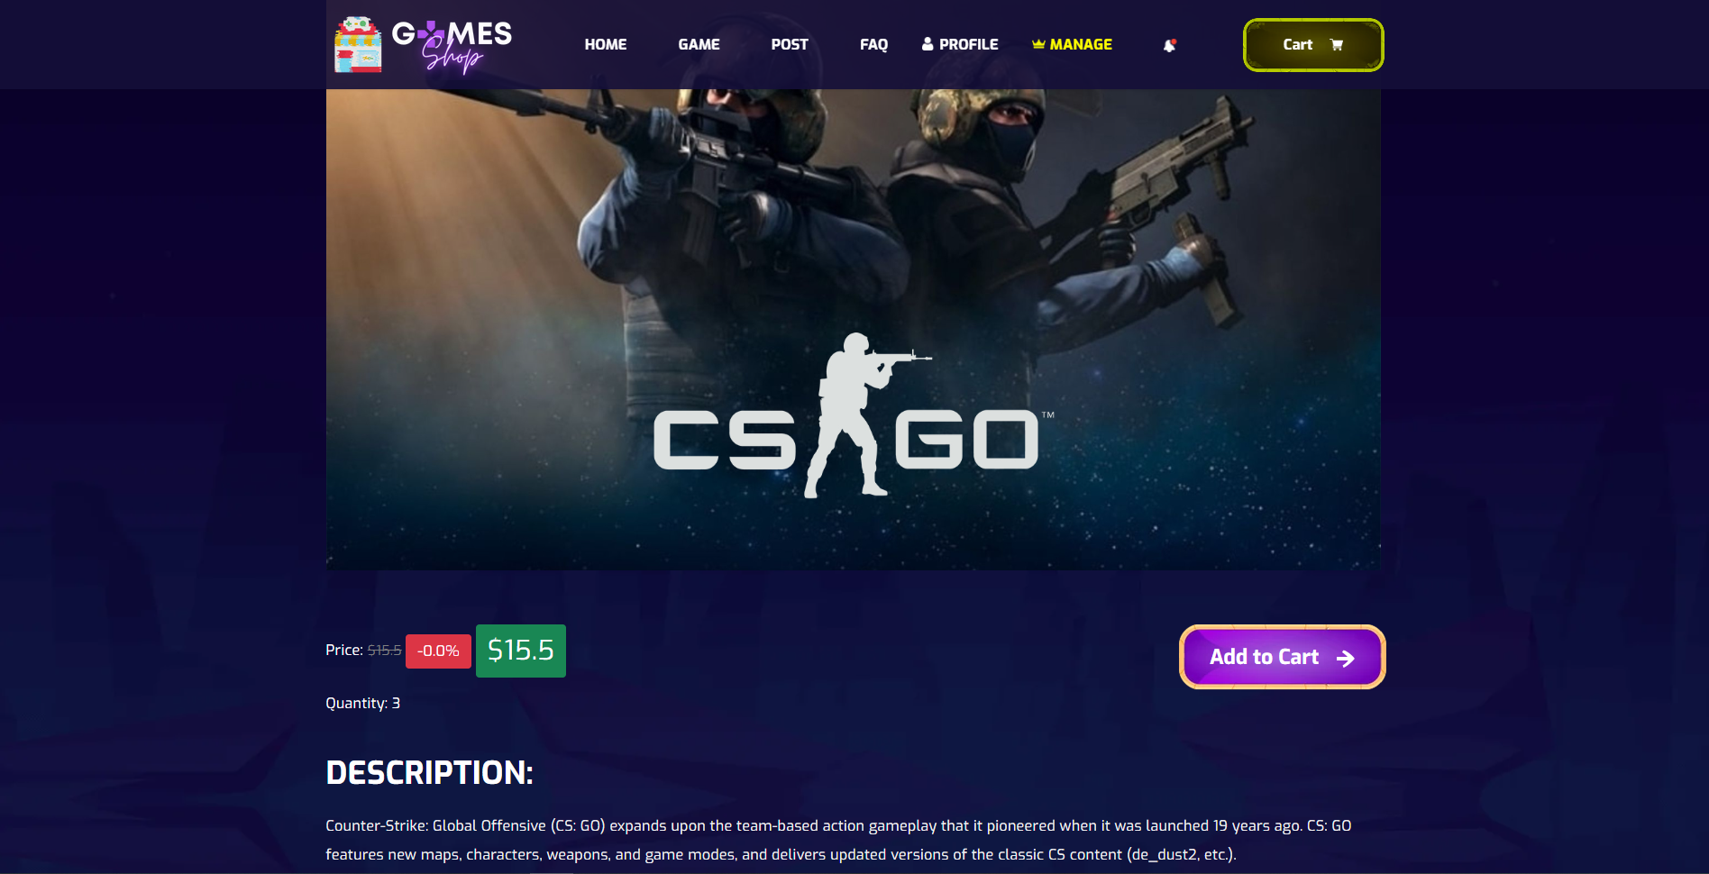
* Figure 2.7.2: Product detail - content

|  |  |  |
| --- | --- | --- |
| **UI Element: View Game Page** | | |
| **UI Element Description** | | |
| ID | 7 | |
| Description | Screen show Product Detail | |
| **UI Element Displays** | | |
| Precondition | Display | |
| User is logged in | Screen show product detail with percent discount, description and sell price but doesn’t show Manager tabs in navigation bar | |
| Staff is logged in | Screen show all and Manager tabs in navigation bar | |
| **UI Element Behaviours** | | |
| **Precondition** | **Action** | **Respond** |
| Staff is not logged in | Input manage url in browser | System will send back an error page and redirect back to home page |
| Staff is logged in | Click on manage in navigation bar or input manage url in browser | System show screen of dashboard and navigator with full function for staff Includes : Product management , post management, category management, account management |
| User | Click on name of product | System will get requestDispatcher to product detail In product detail will show product detail with percent discount, description and sell price. |

## 8. User Profile

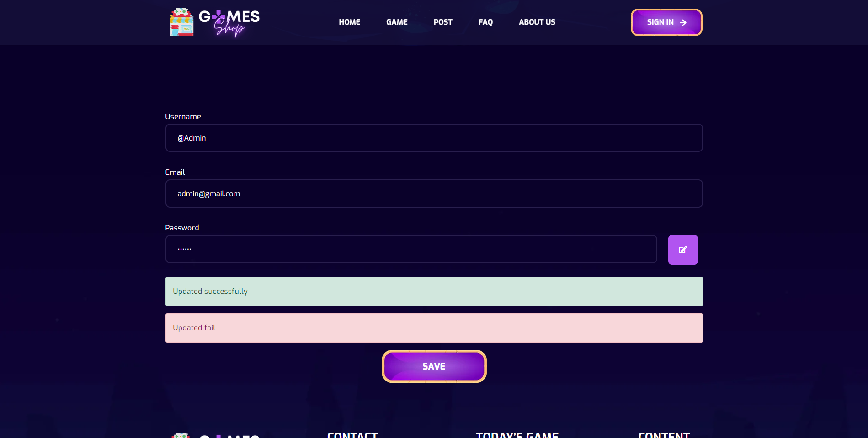

Figure 2.8.1: User profile

|  |  |  |
| --- | --- | --- |
| **UI Element: View User Profile** | | |
| **UI Element Description** | | |
| ID | 8 | |
| Description | Profile screen for user to change their profile | |
| **UI Element Displays** | | |
| Precondition | Connect internet | |
| User not logged in | Screen show Login page | |
| User do not input username | Screen show ERROR alert and require they input username | |
| User input satisfy username, Click Save button | Screen show alert SUCCESS | |
| **UI Element Behaviours** | | |
| **Precondition** | **Action** | **Respond** |
| Staff is not logged in | Click on Profile button at navbar | System will redirect to Login page |
| Staff is logged in | Click on Profile button at navbar | System will redirect to Profile page |

## 9. Change password

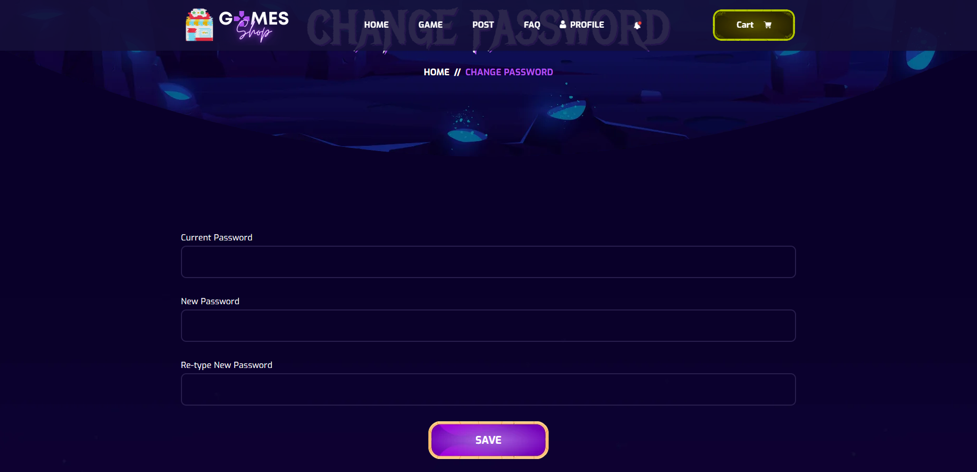

Figure 2.9.1: Change password

|  |  |  |
| --- | --- | --- |
| **UI Element: Change Password** | | |
| **UI Element Description** | | |
| ID | 9 | |
| Description | User input all fields and click save to change password | |
| **UI Element Displays** | | |
| Precondition | Connect internet | |
| User not logged in | Screen show Login page | |
| User do not input | Screen show ERROR alert and require they input all field | |
| User input satisfy all fields, Click Save button | Screen show alert SUCCESS | |
| **UI Element Behaviours** | | |
| **Precondition** | **Action** | **Respond** |
| User is not logged in | User input url /changepassword | System will redirect to Login page |
| User is logged in | Click on Change Password button in Profile at navbar | System will redirect to Change Password page |

## 10. Post

* 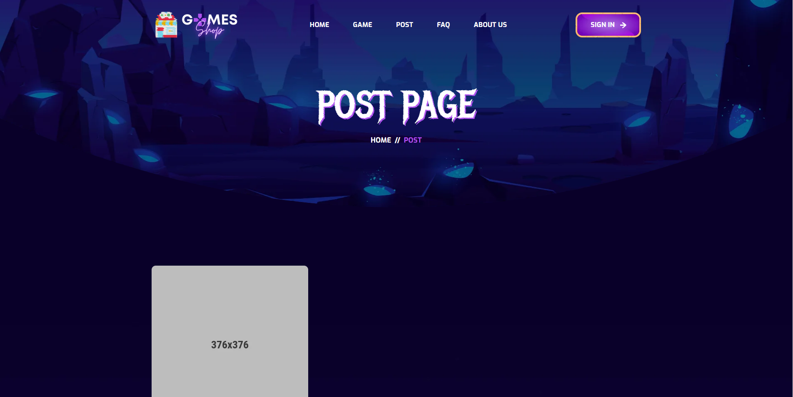
* Figure 2.10.1: Post page

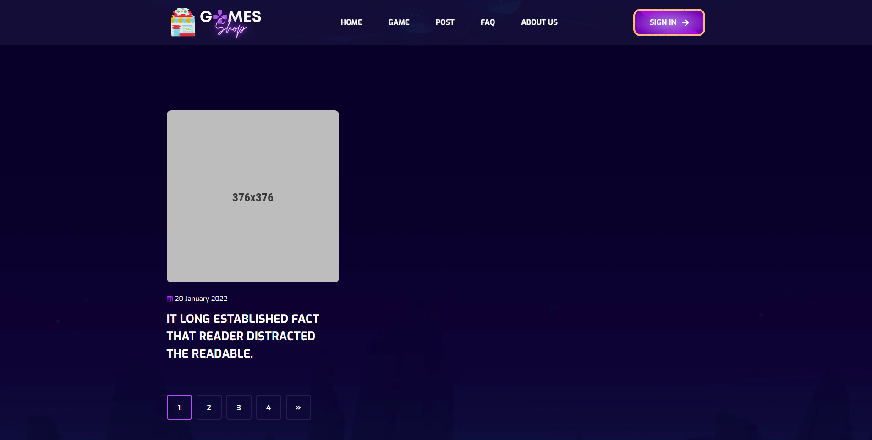

Figure 2.10.2: Post page

|  |  |  |
| --- | --- | --- |
| **UI Element: View Post** | | |
| **UI Element Description** | | |
| ID | 10 | |
| Description | Screen show list all Post | |
| **UI Element Displays** | | |
| Precondition | Connect internet | |
| User is not logged in | Screen show all Post | |
| User is logged in | Screen show all Post | |
| **UI Element Behaviours** | | |
| **Precondition** | **Action** | **Respond** |
| User | Click on Post in navbar | System will redirect to Post page |

## 11. Post Details

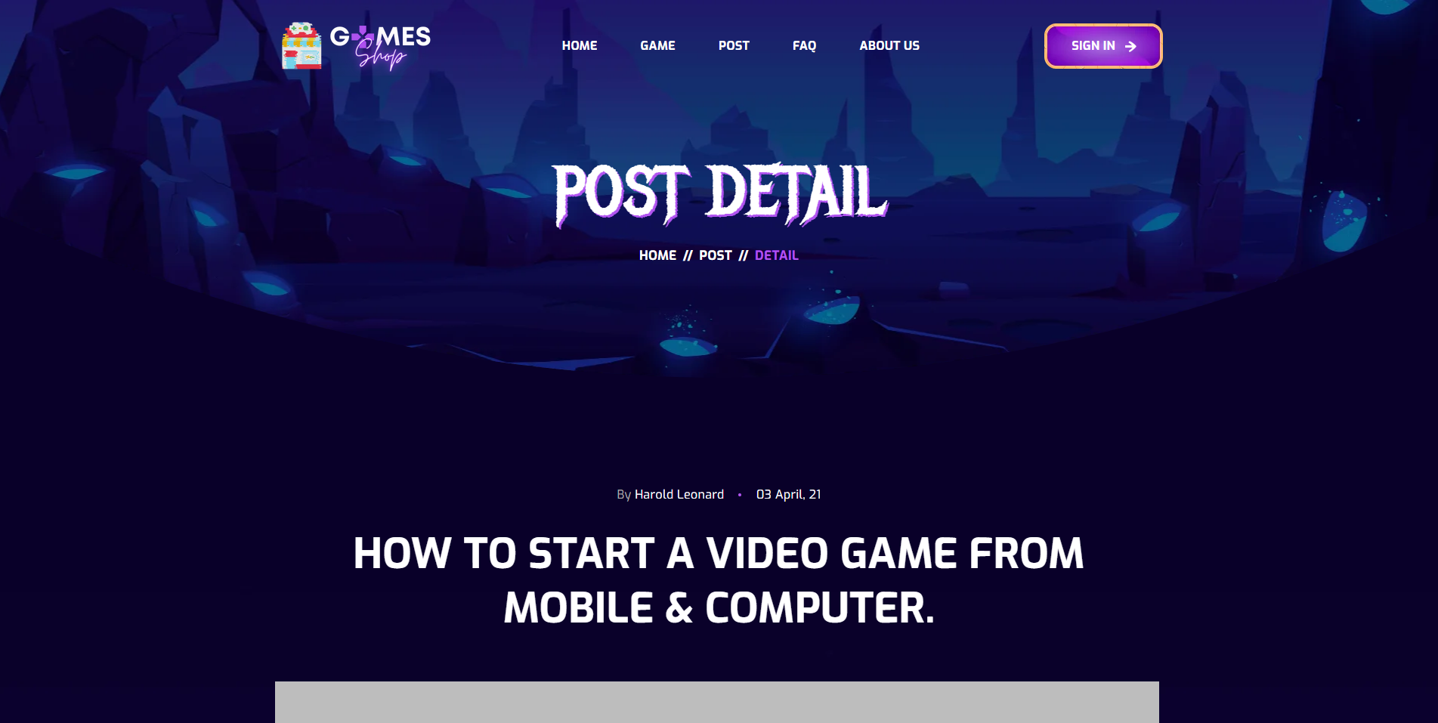

**Figure 2.11.1**: Post title detail

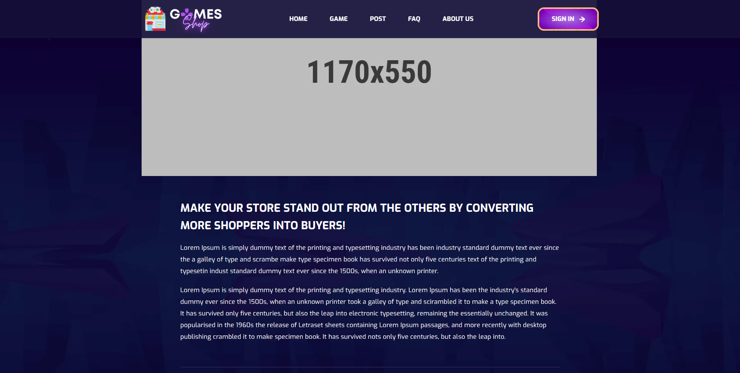

**Figure 2.11.2**: Post conent detail

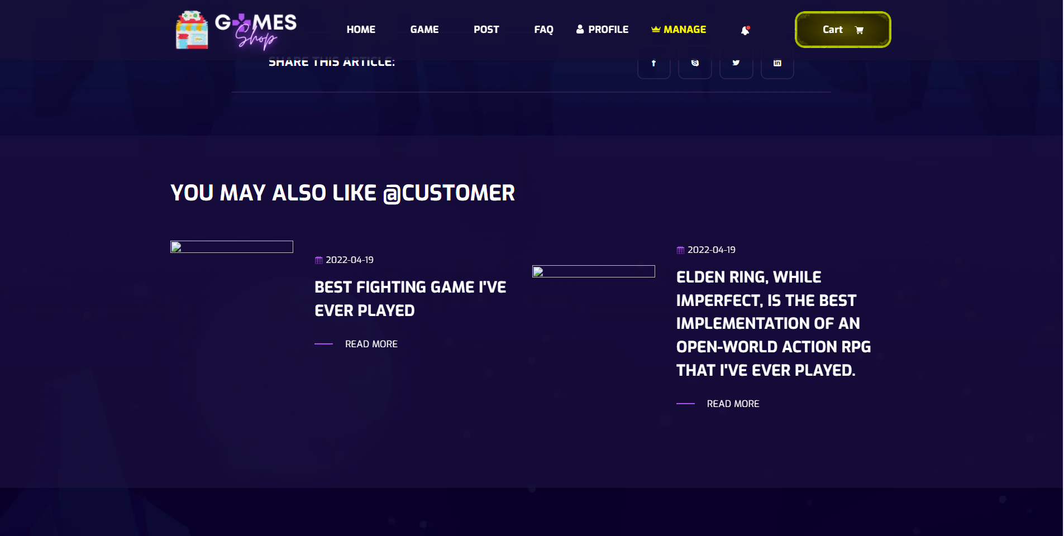

**Figure 2.11.3**: List post of author

|  |  |  |
| --- | --- | --- |
| **UI Element: Post detail** | | |
| **UI Element Description** | | |
| ID | 11 | |
| Description | Screen show Post detail and list posts of that author | |
| **UI Element Displays** | | |
| Precondition | Connect internet | |
| User is not logged in | Screen show Post detail | |
| User is logged in | Screen show Post detail | |
| **UI Element Behaviours** | | |
| **Precondition** | **Action** | **Respond** |
| User | Click on Post title in Post page | System will redirect to that Post detail |

## 12. FAQs

* 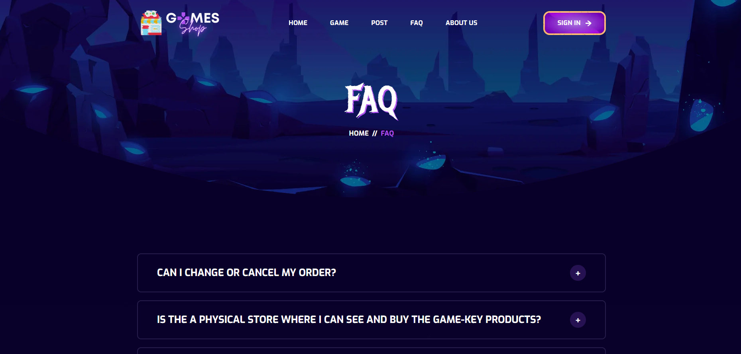

Figure 2.12.1: FAQ List

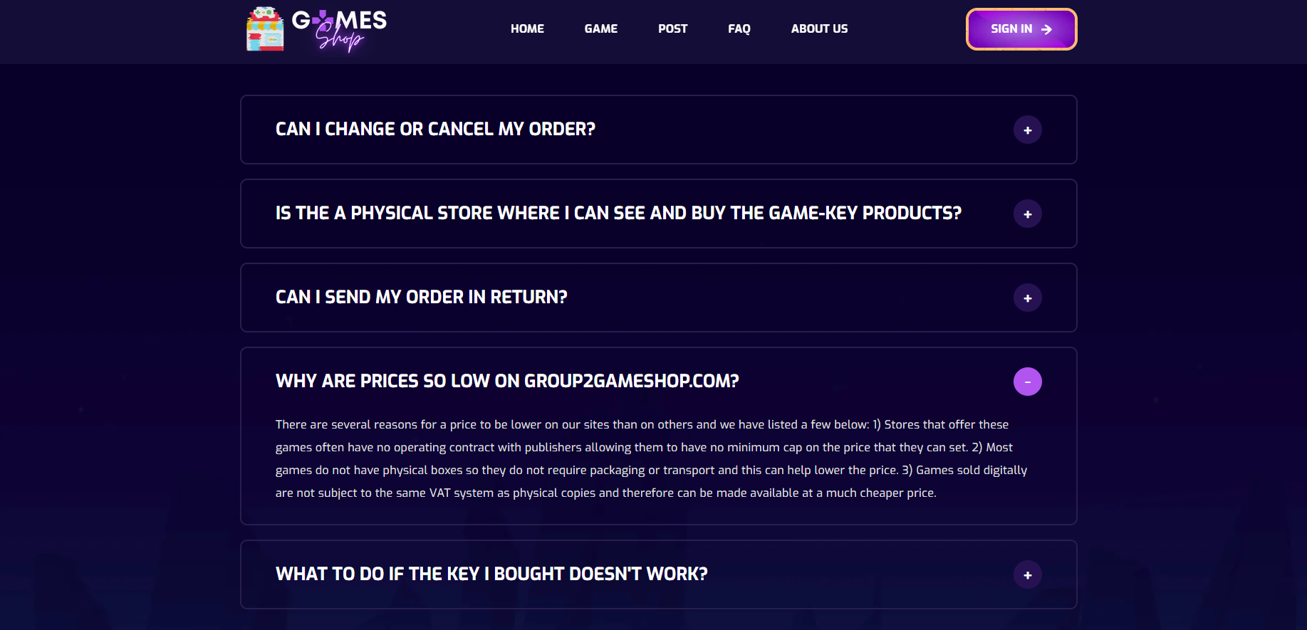

Figure 2.12.2: Click to show collapsed detail of each FAQ

|  |  |  |
| --- | --- | --- |
| **UI Element: View FAQs** | | |
| **UI Element Description** | | |
| ID |  | |
| Description | Screen show FAQs | |
| **UI Element Displays** | | |
| Precondition | Display | |
| Staff is not logged in | Screen show all FAQs | |
| Staff is logged in | Screen show all FAQs | |
| **UI Element Behaviours** | | |
| **Precondition** | **Action** | **Respond** |
| User | Click on FAQ in navbar | System will redirect to FAQ page |

## 13. Notification

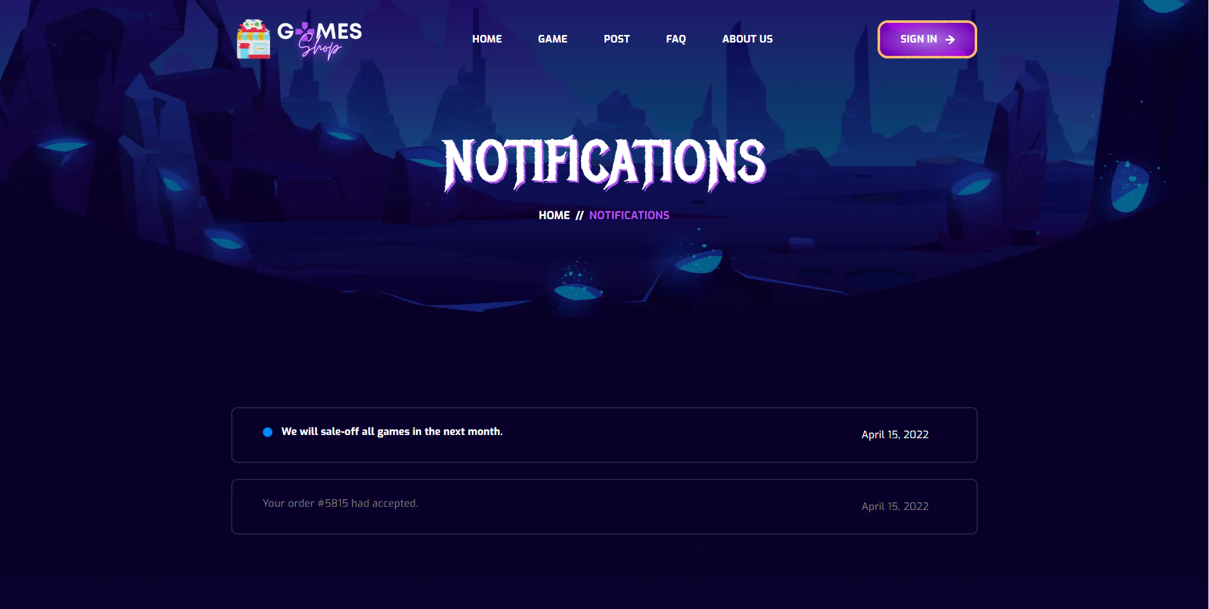

- Data initializing in screen components:  
- Business logics inside:  
- Data validations:  
- Functionalities:

**14. Cart**

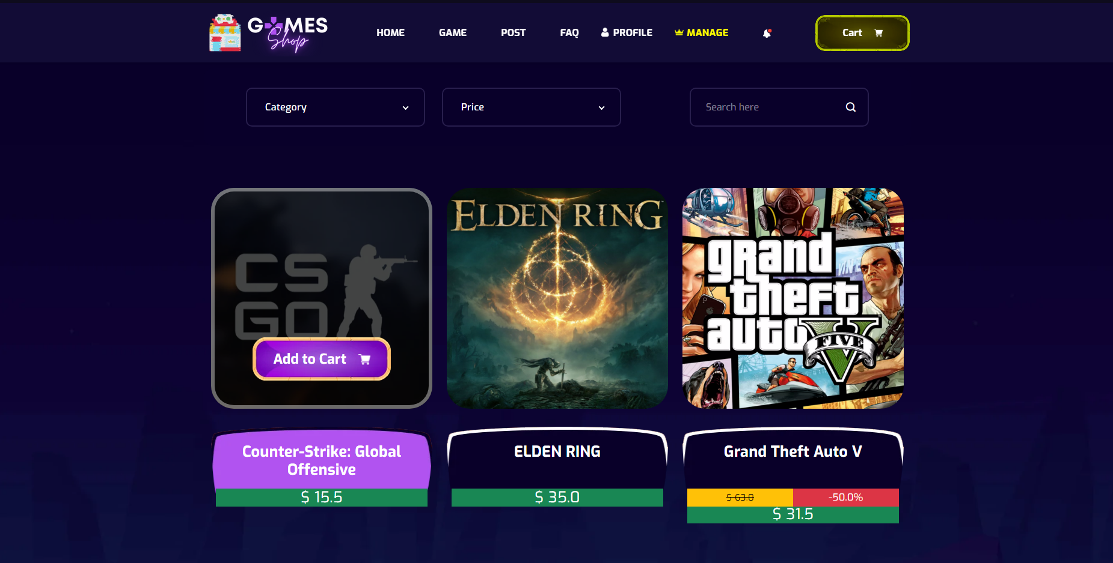

Figure 2.14.1: Button Add to cart in Game Page

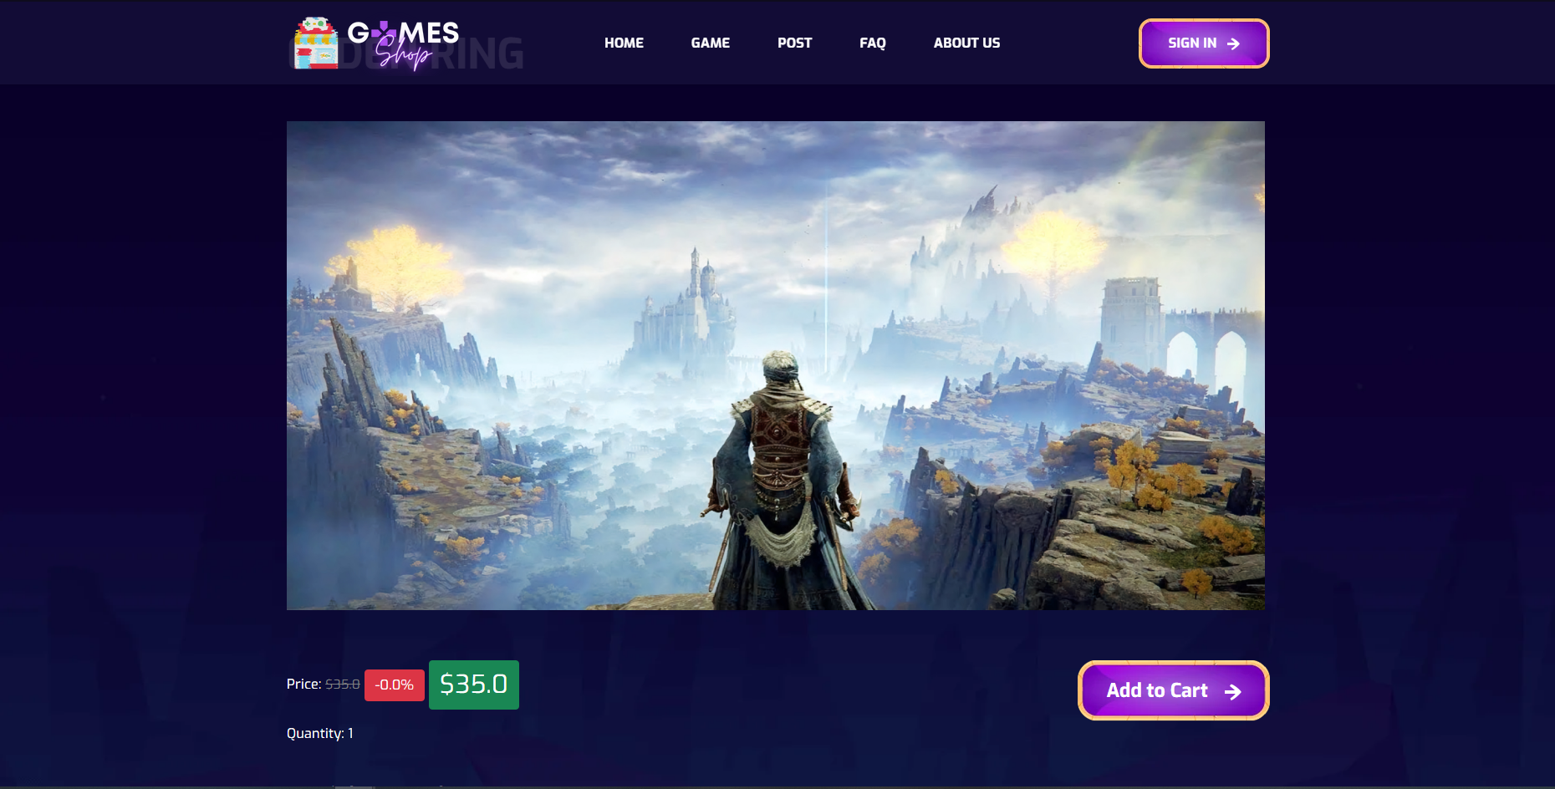

Figure 2.14.2: Button Add to cart in Game Detail

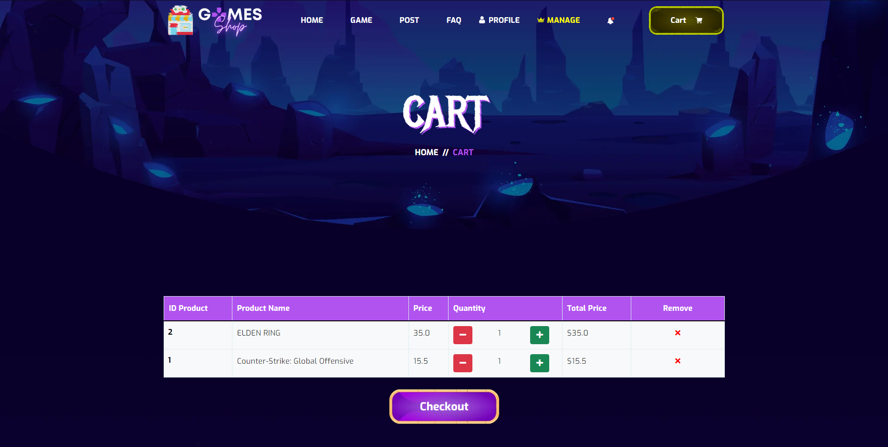

Figure 2.14.3: Cart Page

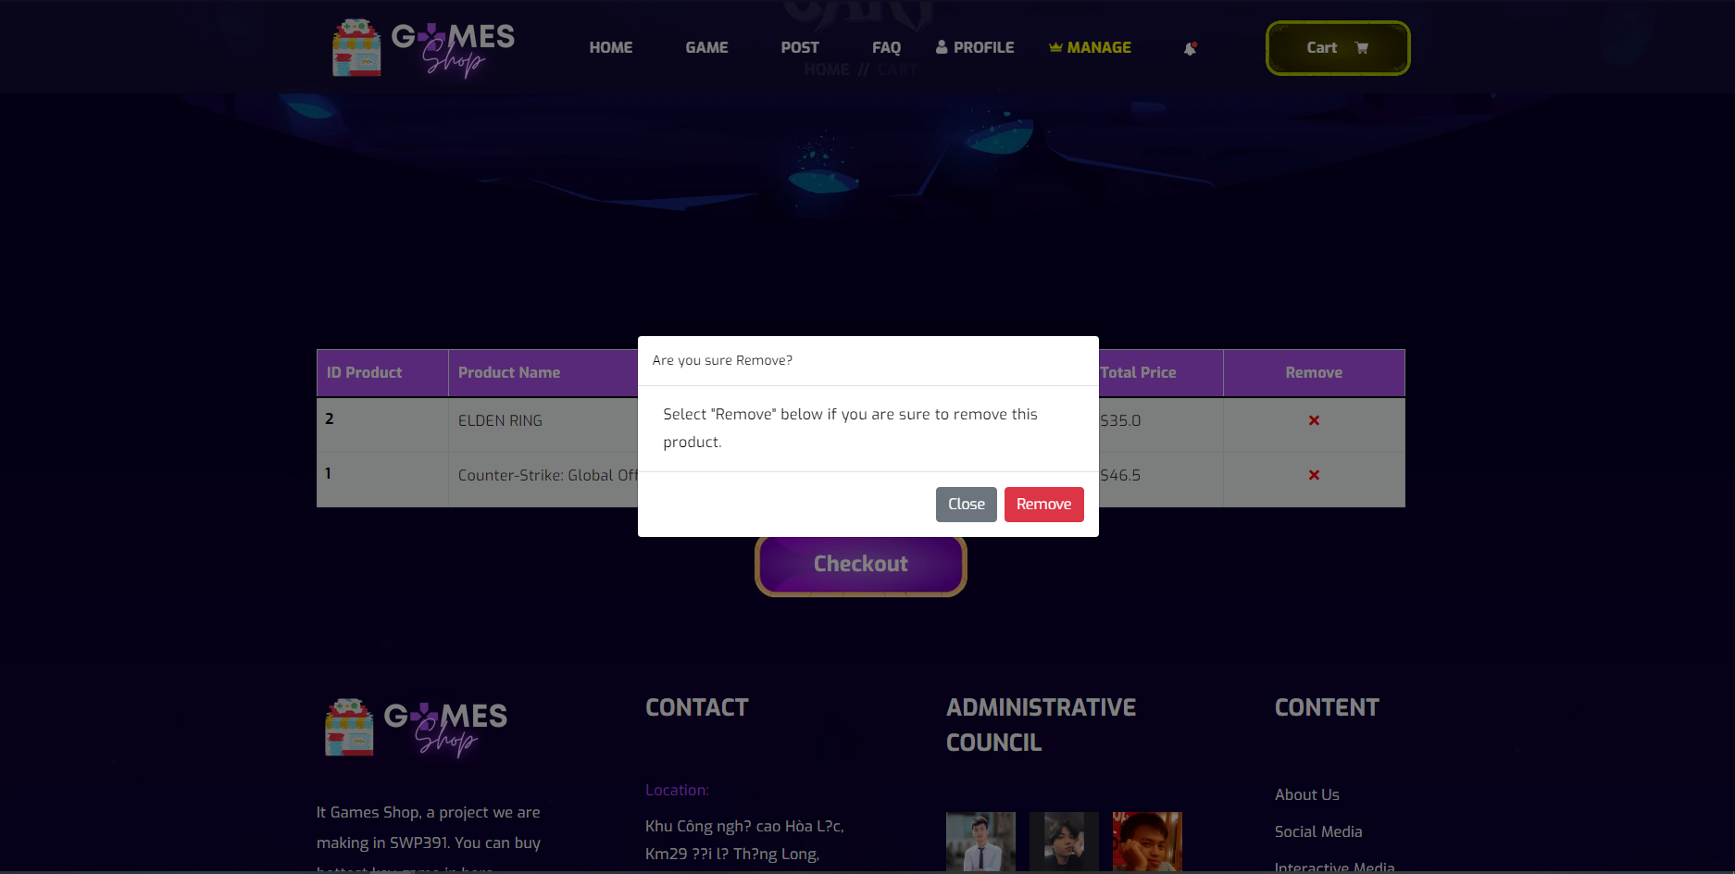

Figure 2.14.4: Modal remove

|  |  |  |
| --- | --- | --- |
| **UI Element: View Customer Information** | | |
| **UI Element Description** | | |
| ID | 14 | |
| Description | Screen show Cart | |
| **UI Element Displays** | | |
| Precondition | Display | |
| Staff is not logged in | Screen show all product but doesn’t show Manager tabs in navigation bar | |
| Staff is logged in | Screen show all and Manager tabs in navigation bar | |
| **UI Element Behaviours** | | |
| **Precondition** | **Action** | **Respond** |
| Staff is not logged in | Input manage URL in browser | System will send back an error page and redirect back to home page |
| Staff is logged in | Click on manage in navigation bar or input manage URL in browser | System show screen of dashboard and navigator with full function for staff Includes: Product management, post management, category management, account management |
| User | Click on the cart button | System will send to Cart Page |
| User | Click the button Add to cart | System will send notifications that add to cart successfully. |
| User | On cart page, user click on plus button | Quantity of product you click will + 1 |
| User | On cart page, user click on minus button | Quantity of product you click will - 1 |
| User | On cart page, user click on remove button | System will show modal that confirm to remove the product from the cart. |

**15. Checkout**

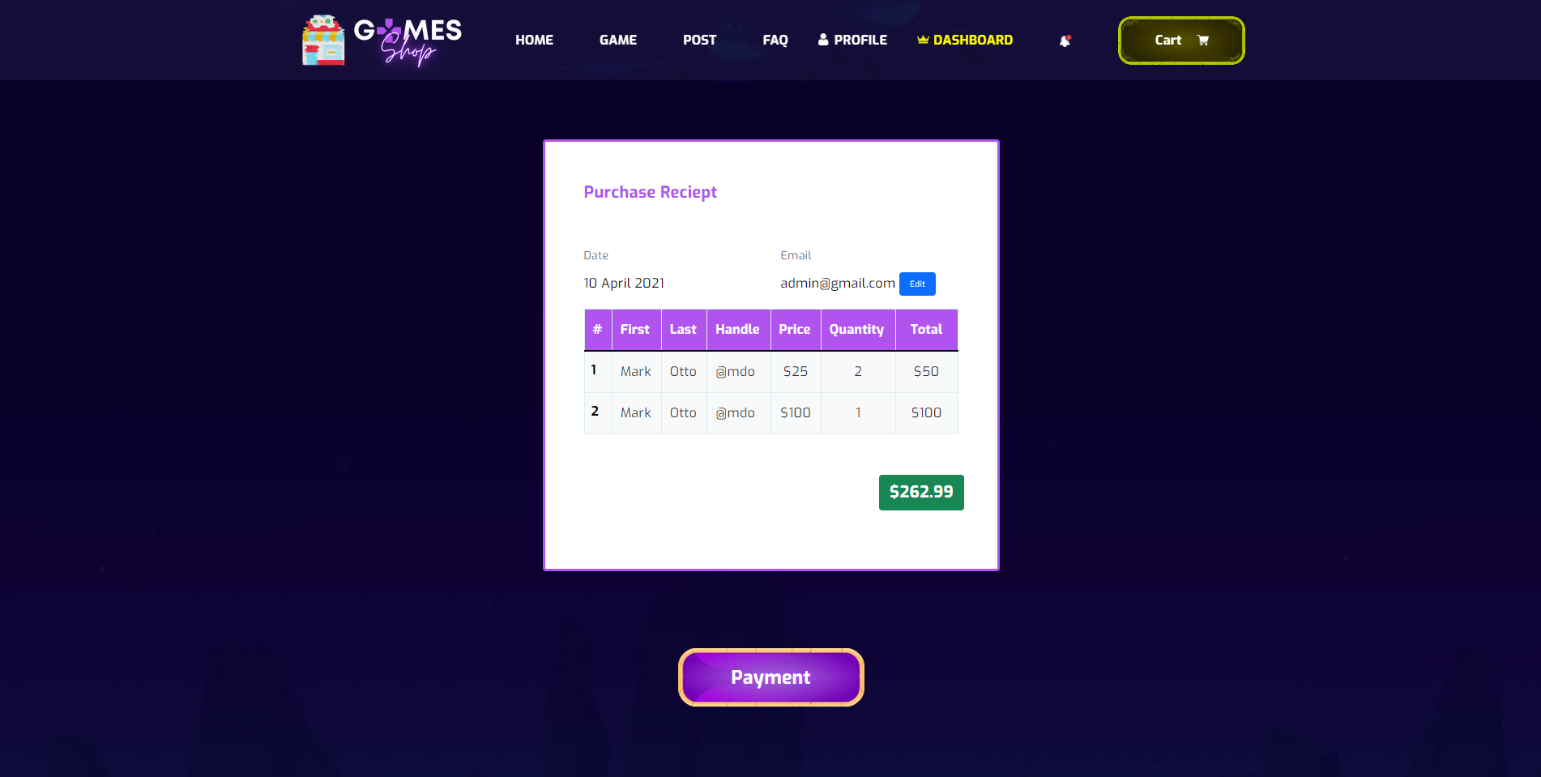

- Data initializing in screen components:  
- Business logics inside:  
- Data validations:  
- Functionalities:

**16. Payment**

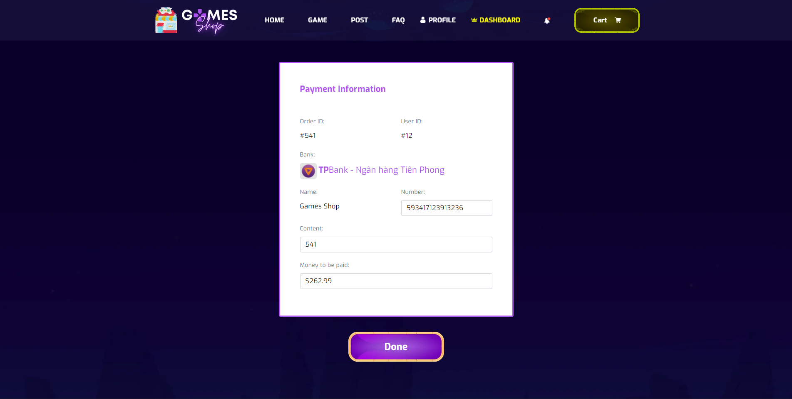

- Data initializing in screen components:  
- Business logics inside:  
- Data validations:  
- Functionalities:

**17. Order History**

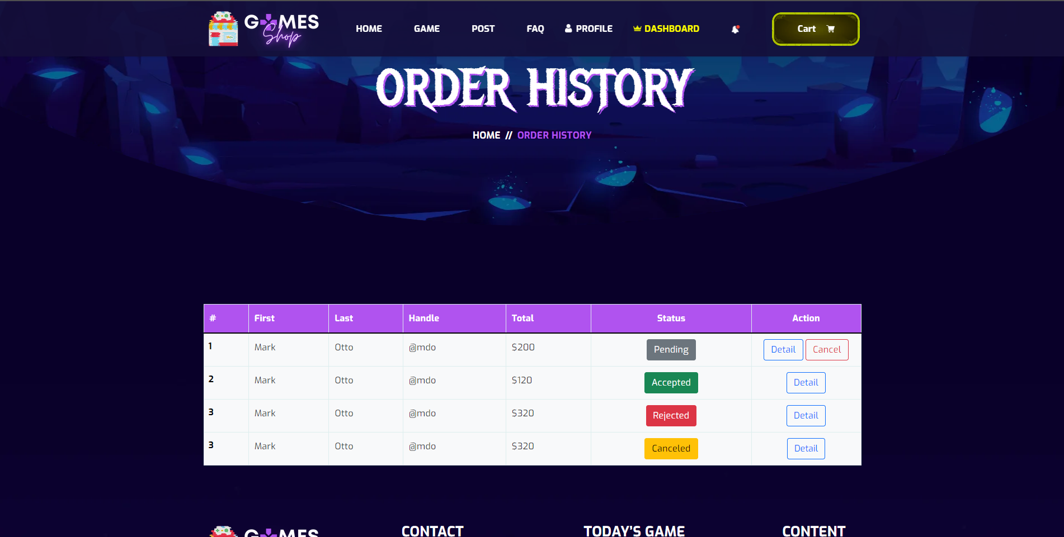

- Data initializing in screen components:  
- Business logics inside:  
- Data validations:  
- Functionalities:

**18. Order History Detail**

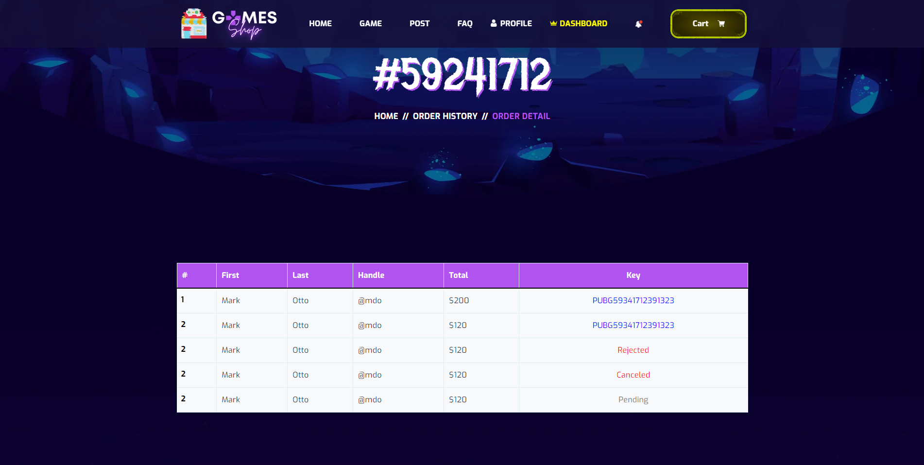

- Data initializing in screen components:  
- Business logics inside:  
- Data validations:  
- Functionalities:

19. **Dashboard**

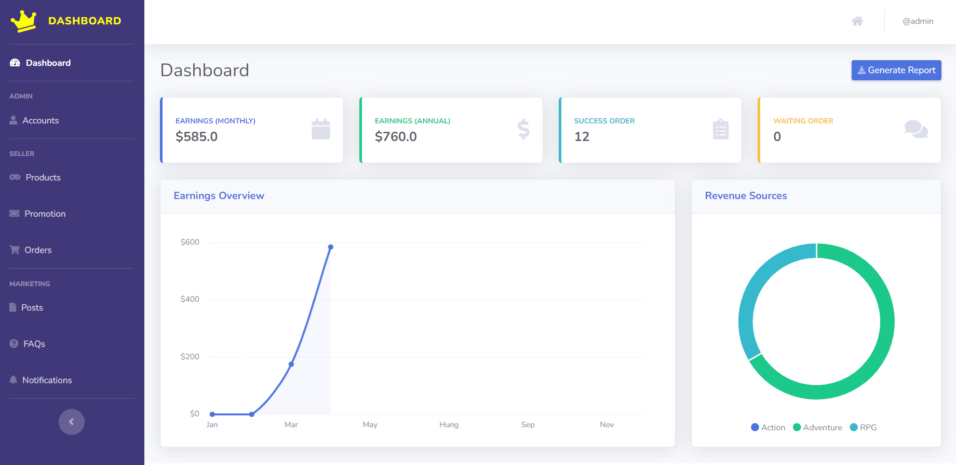

**Figure 2.19.1:** Screen Dashboard shows all store income information

(Login with role Admin)

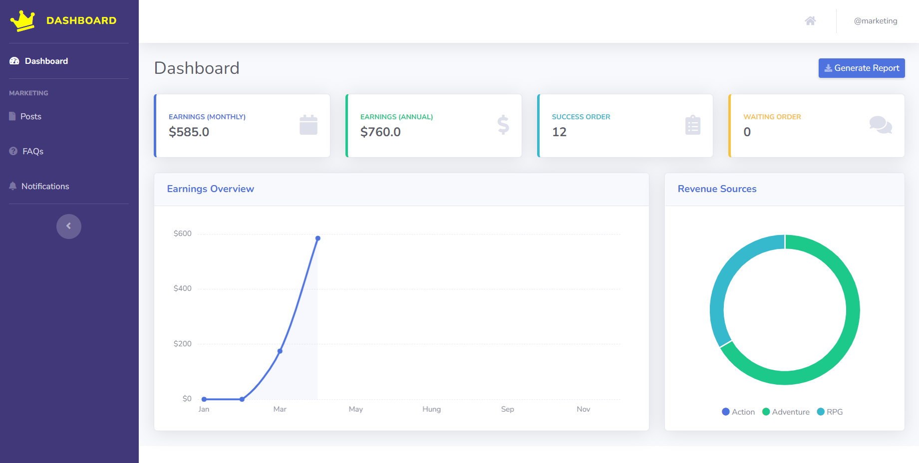

**Figure 2.19.2:** Screen Dashboard shows all store income information

(Login with role Marketing)

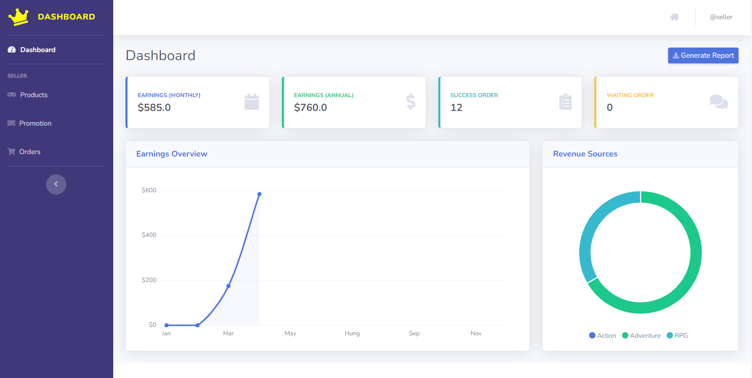

**Figure 2.19.3:** Screen Dashboard shows all store income information

(Login with role Seller)

|  |  |  |
| --- | --- | --- |
| **UI Element: View shows all store income information** | | |
| **UI Element Description** | | |
| ID | 19 | |
| Description | Screen show Dashboard | |
| **UI Element Displays** | | |
| Precondition | Display | |
| Staff is logged in | Screen show all store income information | |
| **UI Element Behaviours** | | |
| **Precondition** | **Action** | **Respond** |
| Staff are logged in | Click on Account in list dasdboard | Take Staff to the user account management page |
| Staff are logged in | Click on Product in list dasdboard | Take Staff to the product management page |
| Staff are logged in | Click on Promotion in list dasdboard | Take Staff to the promotion management page |
| Staff are logged in | Click on Order in list dasdboard | Take Staff to the order management page |
| Staff are logged in | Click on Post in list dasdboard | Take Staff to the post-management page |
| Staff are logged in | Click on FAQs in list dasdboard | Take Staff to the FAQs management page |
| Staff are logged in | Click on the notification in list dasdboard | Take Staff to the notification management page |



20. **Account Management**

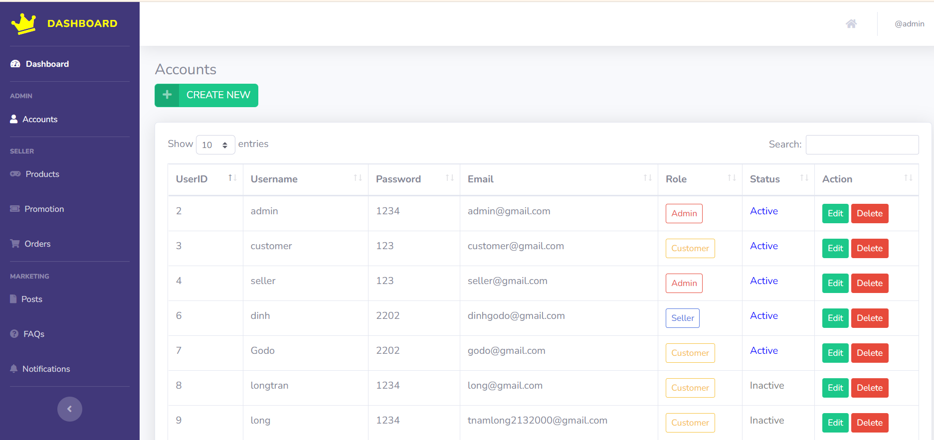

Figure 2.20.1: List of Account

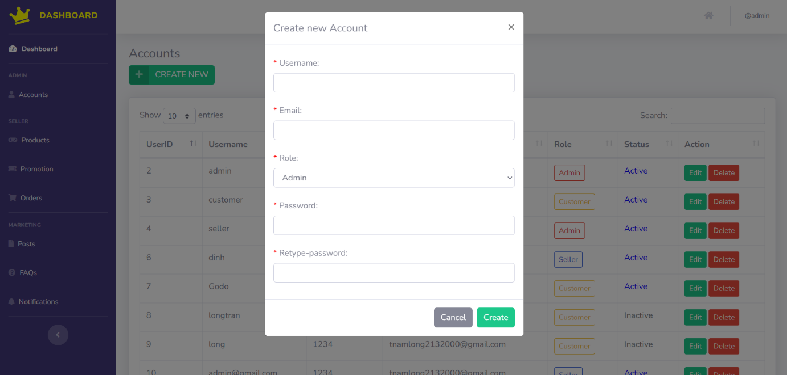

Figure 2.20.2: Create Account

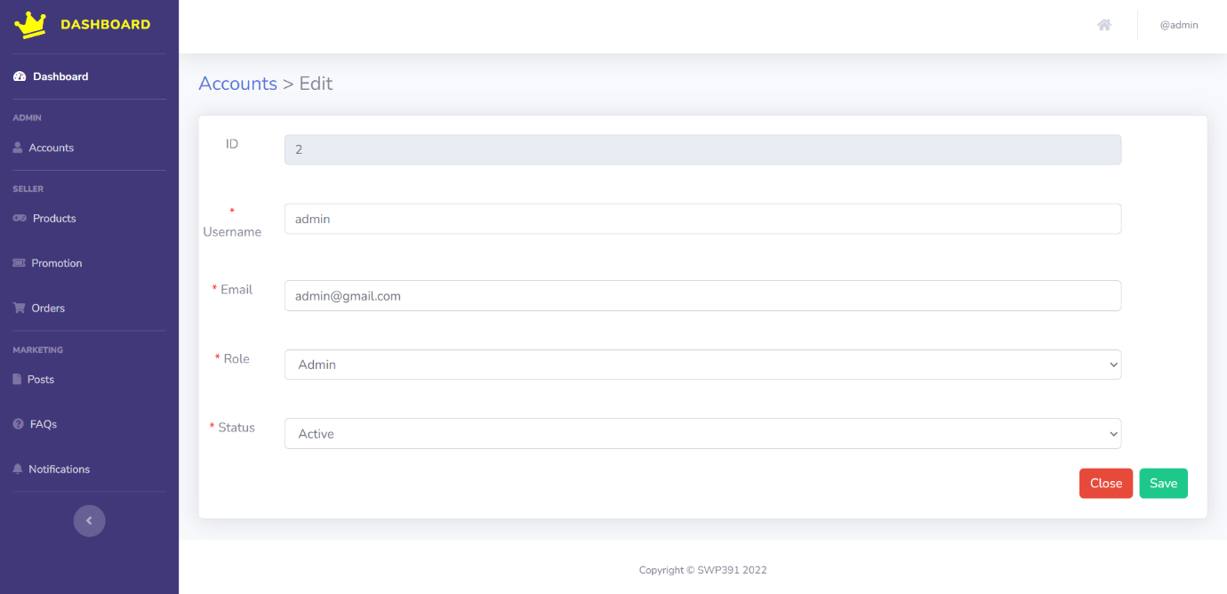

Figure 2.20.3: Edit Account

|  |  |  |
| --- | --- | --- |
| **UI Element: View List Account Management** | | |
| **UI Element Description** | | |
| ID | 20 | |
| Description | Screen show Account Management | |
| **UI Element Displays** | | |
| Precondition | Display | |
| Staff is not logged in | Screen don’t show anything | |
| Staff is logged in | Screen show all accounts | |
| **UI Element Behaviours** | | |
| **Precondition** | **Action** | **Respond** |
| Staff is not logged in | Input manage URL in Browser | System will send back an error page and redirect back to home page |
| Staff is logged in | Click on Manage in navigation bar and then Accounts in sidebar or Input Account Manage URL in Browser | System will show screen of dashboard with full functions of staff includes : Create Account , Edit Account and Delete Account |

21. **Product Management**

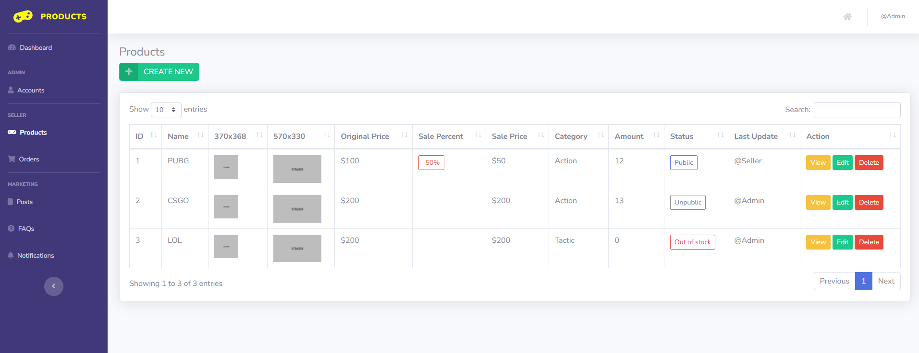

Figure 2.21.1: Product list

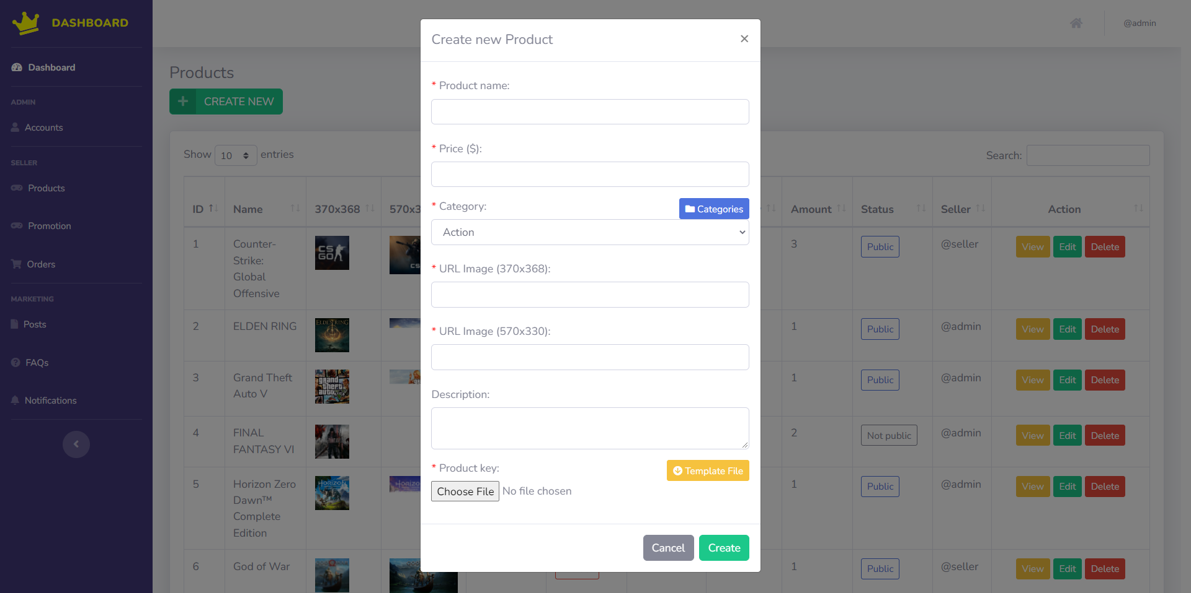

Figure 2.21.2: Create new product

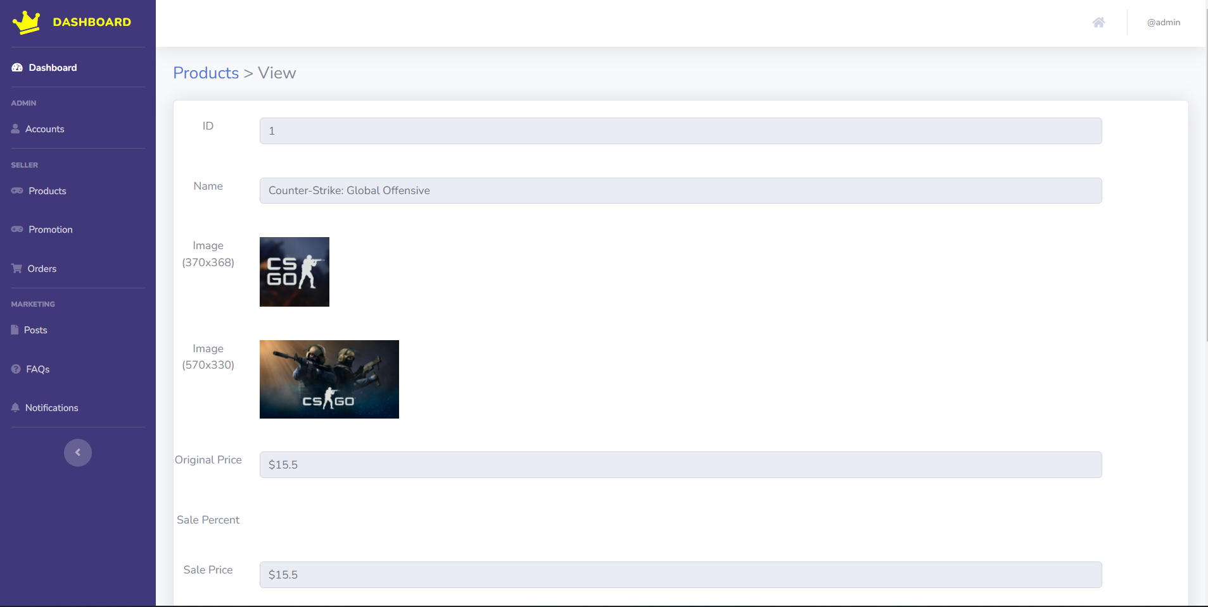

Figure 2.21.3: View product

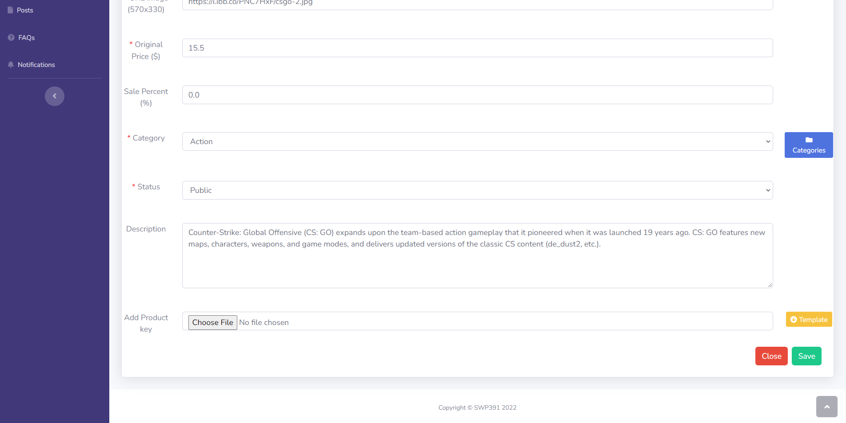

Figure 2.21.4: Edit product

|  |  |  |
| --- | --- | --- |
| **UI Element: Product management** | | |
| **UI Element Description** | | |
| ID | 21 | |
| Description | Product management show list all products, seller also can Create new, view, edit and delete product | |
| **UI Element Displays** | | |
| Precondition | Connect internet | |
| Staff are not logged in | Screen don’t show anything | |
| Staff are logged | Screen show Product Management list page | |
| Staff are click on “Create new” button | Screen show Create modal | |
| Staff are click on “View” button | Screen show View detail product page | |
| Staff are click on “Edit” button | Screen show Edit product page | |
| Staff are click on “Delete” button | Screen show Delete modal | |
| **UI Element Behaviors** | | |
| **Precondition** | **Action** | **Respond** |
| Staff are not logged in | Input Product Management url page in browse | System will redirect to Homepage |
| Staff are logged in | Click on Product tab in Manage sidebar | System will redirect to Product Management |

22. **Categories Dashboard**

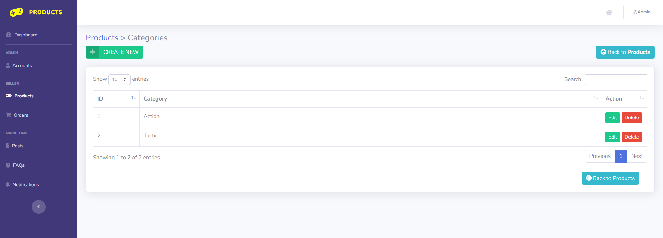

Figure 2.22.1: Category list

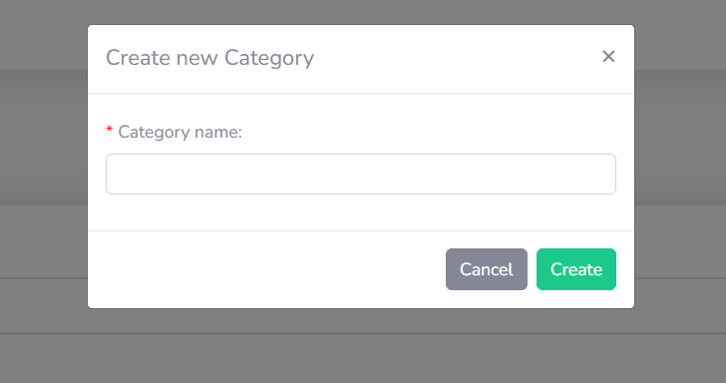

Figure 2.22.2: Create new category

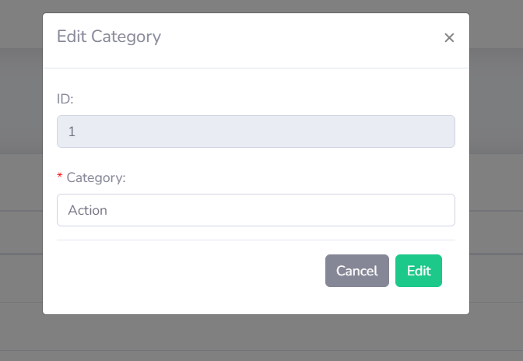

Figure 2.22.3: Edit category

|  |  |  |
| --- | --- | --- |
| **UI Element: Category management** | | |
| **UI Element Description** | | |
| ID | 22 | |
| Description | Category Management display and manage all category | |
| **UI Element Displays** | | |
| Precondition | Connect internet | |
| Staff are not logged in | Screen don’t show anything | |
| Staff are logged | Screen show Category Management list page | |
| Staff are click on “Create new” button | Screen show Create modal | |
| Staff are click on “Edit” button | Screen show Edit category page | |
| Staff are click on “Delete” button | Screen show Delete modal | |
| **UI Element Behaviors** | | |
| **Precondition** | **Action** | **Respond** |
| Staff are not logged in | Input Category Management url page in browse | System will redirect to Homepage |
| Staff are logged in | Click on Category button in Product Management page | System will redirect to Category Management |

23. **Order Dashboard**

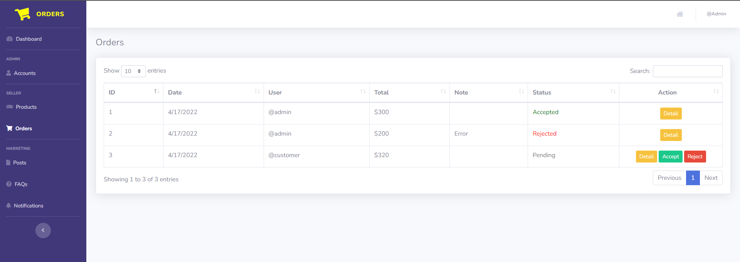- Data initializing in screen components:  
- Business logics inside:  
- Data validations:  
- Functionalities:

24. **Posts Dashboard**

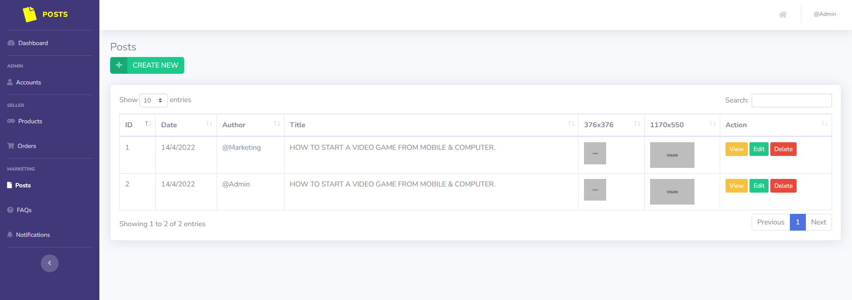- Data initializing in screen components:  
- Business logics inside:  
- Data validations:  
- Functionalities:

25. **FAQs Dashboard**

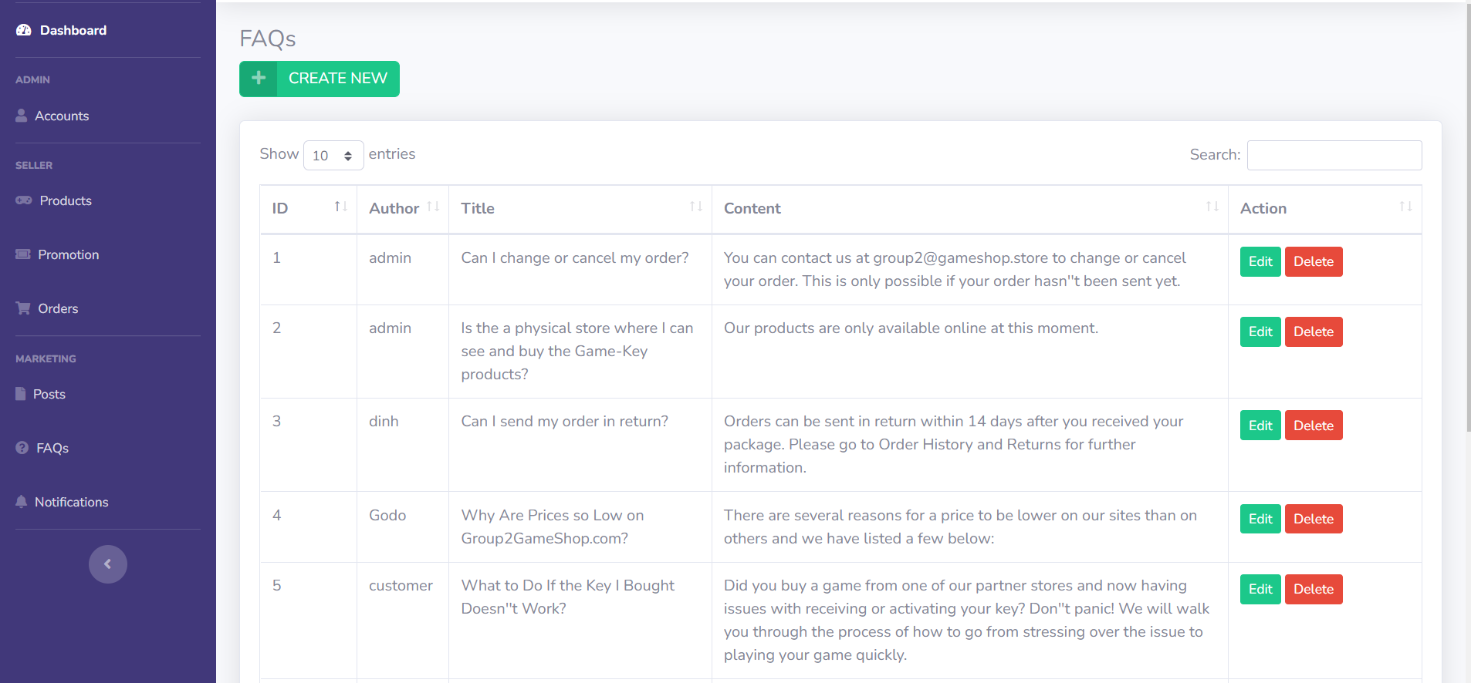 Figure 2.25.1: List FAQs Management

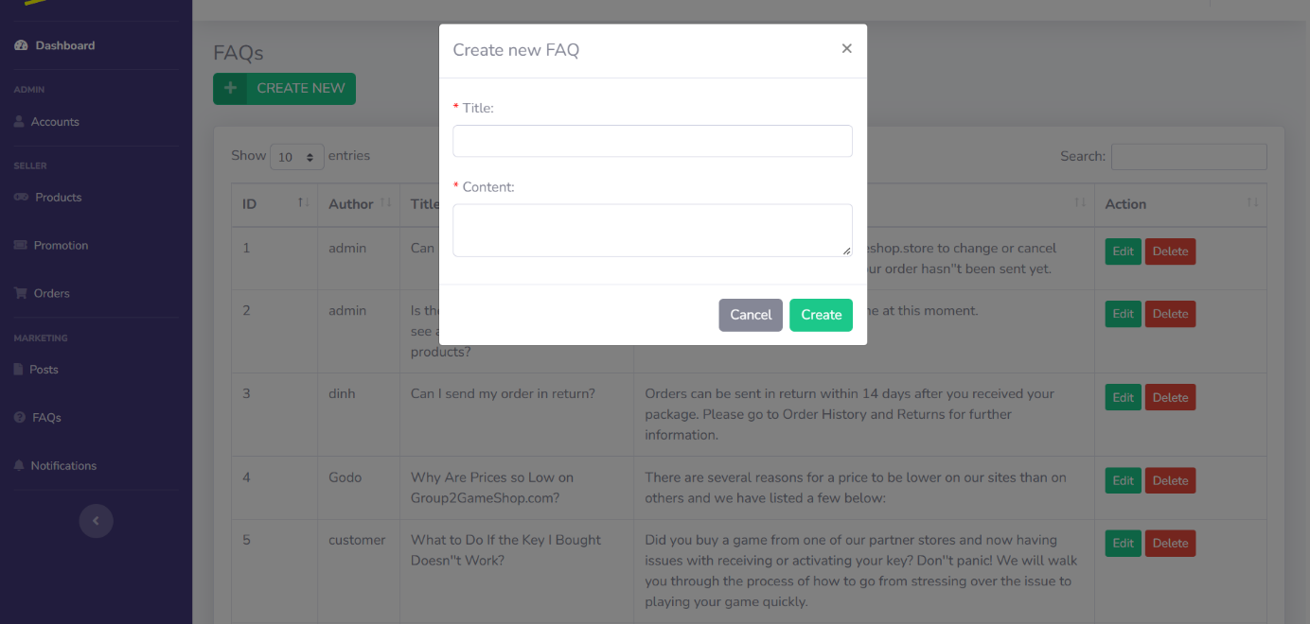

Figure 2.25.2: Create FAQ

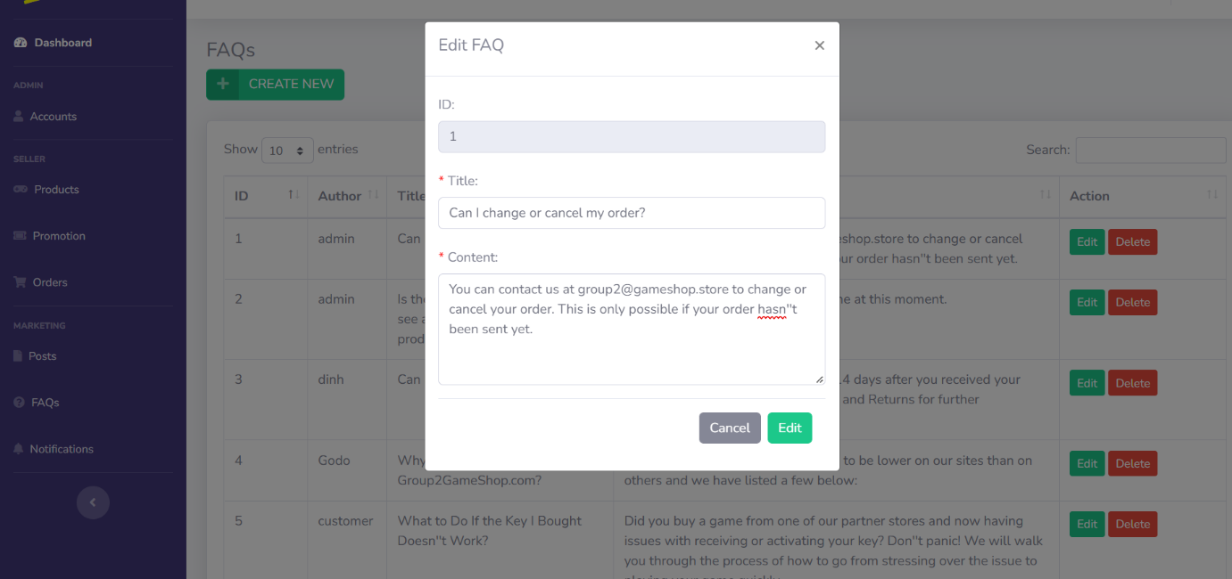

Figure 2.25.3: Edit FAQ

|  |  |  |
| --- | --- | --- |
| **UI Element: View Customer Information** | | |
| **UI Element Description** | | |
| ID | 25 | |
| Description | Screen show FAQs Management | |
| **UI Element Displays** | | |
| Precondition | Display | |
| Staff is not logged in | Screen don’t show anything | |
| Staff is logged in | Screen show all FAQs | |
| **UI Element Behaviours** | | |
| **Precondition** | **Action** | **Respond** |
| Staff is not logged in | Input manage URL in Browser | System will send back an error page and redirect back to home page |
| Staff is logged in | Click on Manage in navigation bar and then FAQs in sidebar or Input Account Manage URL in Browser | System will show screen of dashboard with full functions of staff includes : Create FAQs , Edit FAQs and Delete FAQs |

26. **Notifications Dashboard**

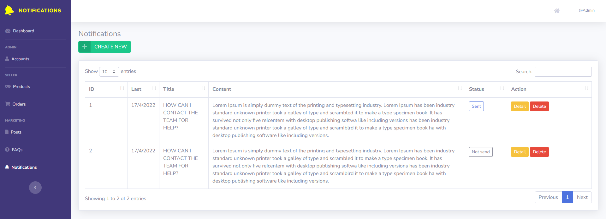- Data initializing in screen components:  
- Business logics inside:  
- Data validations:  
- Functionalities:

## 27. Product Review

* 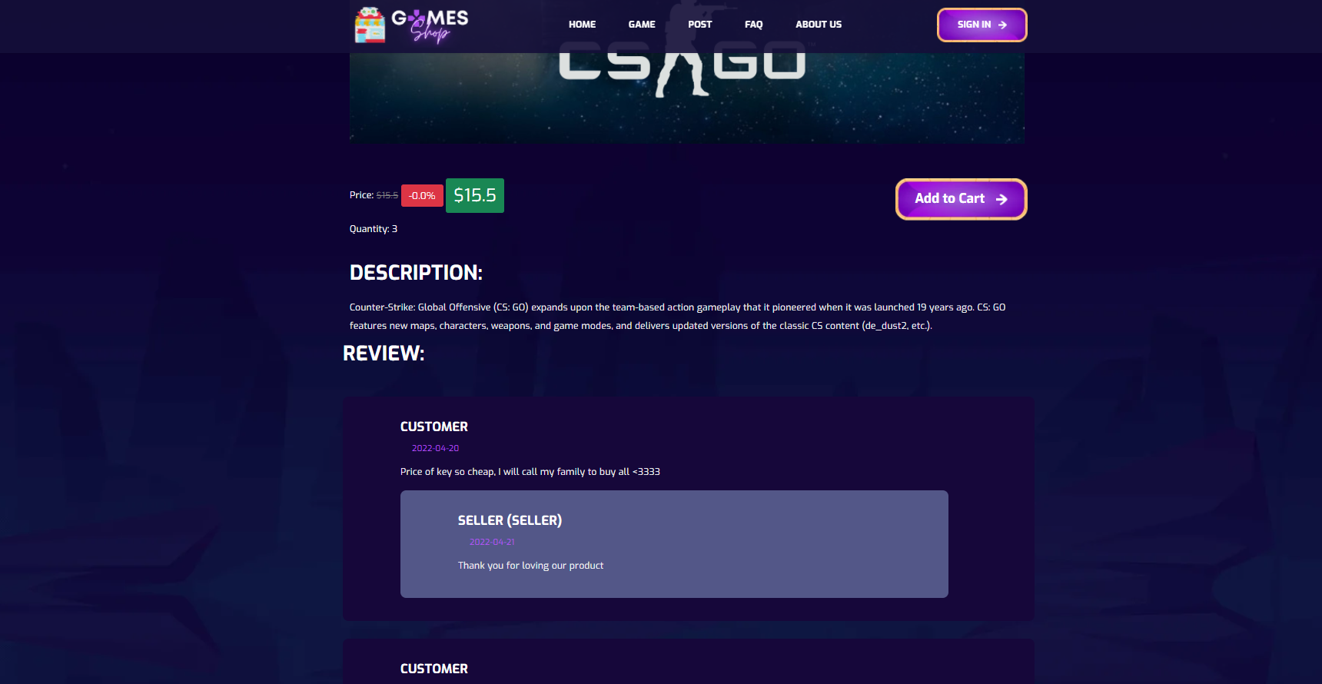

Figure 2.27.1: Review list in Product detail

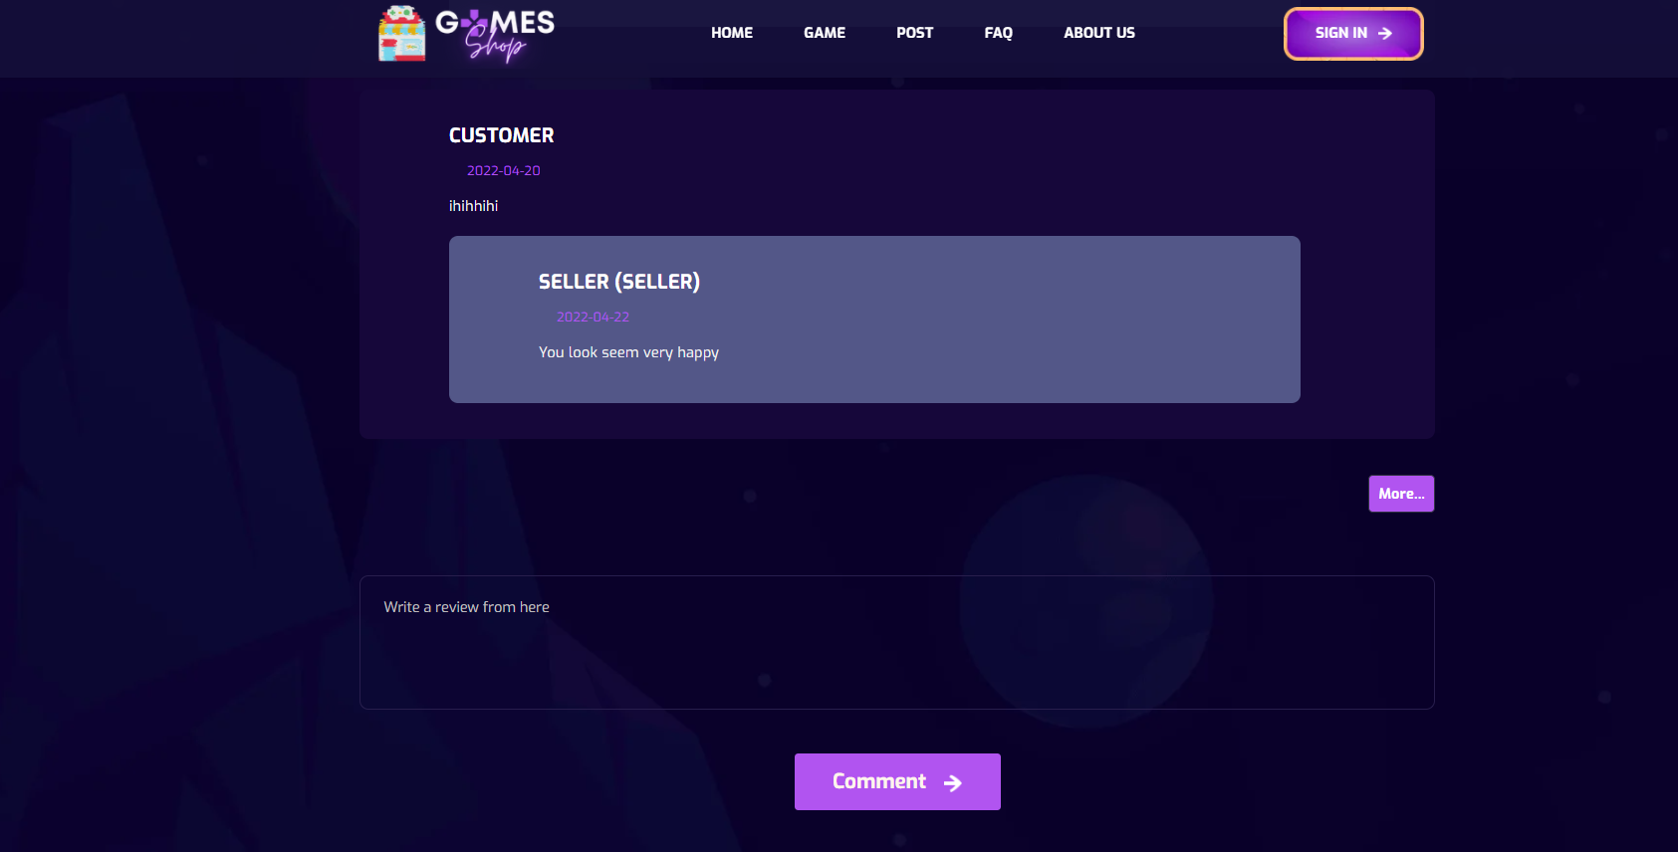

Figure 2.27.2: Review box to input new review for customer

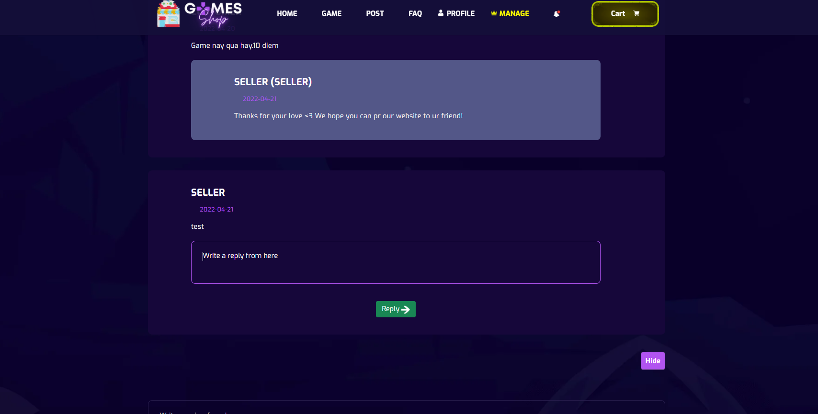

Figure 2.27.3: Review box to input new review for customer

|  |  |  |
| --- | --- | --- |
| **UI Element: Product Review** | | |
| **UI Element Description** | | |
| ID |  | |
| Description | Users click on any product to show detail. Scroll down to view Review, Reply. Users can comment. Seller and Marketer can reply user’s review | |
| **UI Element Displays** | | |
| Precondition | Connect Internet | |
| User is not logged in | Screen show all review, reply review of product | |
| User is logged in | Screen show all review, reply review of product | |
| Staff is not logged in | Screen show all review, reply review of product, not show reply fields for review | |
| Staff is logged in | Screen show all review, reply of product, reply fields for review | |
| Staff input new reply for any review | Screen show alert success and reload to show new reply of review | |
| **UI Element Behaviours** | | |
| **Precondition** | **Action** | **Respond** |
| User | Click on any product | System will redirect to product detail page, show all review,reply of review |
| Staff is not logged in | Click on any product | System will redirect to product detail page, show all review, reply of review |
| Staff is logged in | Click on any product | System will redirect to product detail page show all review, reply of review, show reply fields for which review with no reply |

## 28. Promotion dashboard

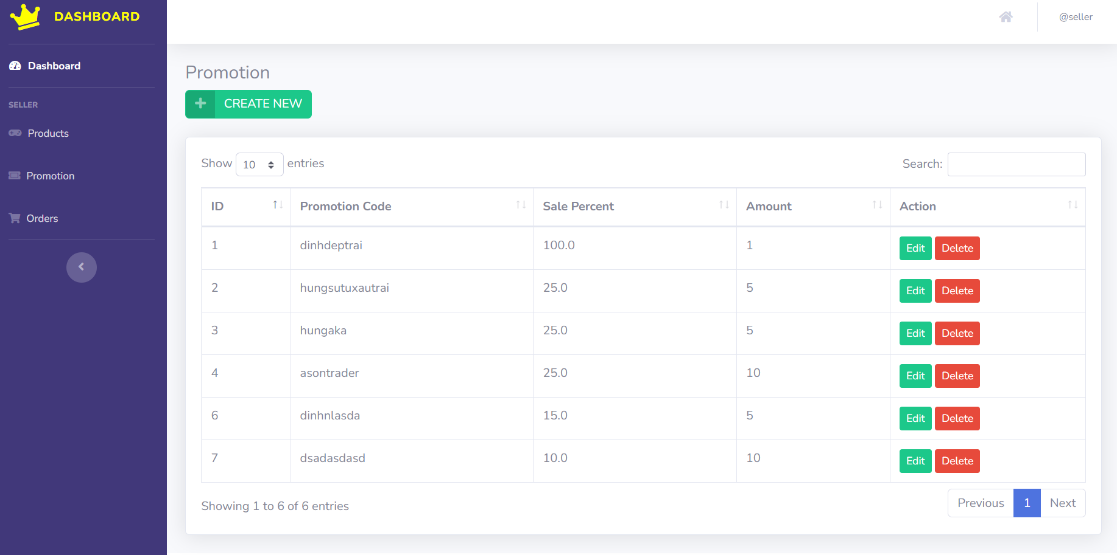

Figure 2.28.1: List Promotion Management

|  |  |  |
| --- | --- | --- |
| **UI Element: View shows all store income information** | | |
| **UI Element Description** | | |
| ID | 28 | |
| Description | Screen show Promotion Dashboard | |
| **UI Element Displays** | | |
| Precondition | Display | |
| Staff is logged in | Screen show all list promotion | |
| **UI Element Behaviours** | | |
| **Precondition** | **Action** | **Respond** |
| Staff are logged in | Click on Create new | Take Staff to the create new promotion modal |
| Staff are logged in | Click on Edit | Take Staff to the Edit page |
| Staff are logged in | Click on Delete | The user deletes the promotion code they want and reloads the page |
| Staff are logged in | Click on Next | To go to the next page of the promotion code |
| Staff are logged in | Click on Previous | To return to the previous page of the promotion code |